——CH1
Abstraction(抽象) can be defined as:
- Any model that includes the most important, essential, or distinguishing aspects of something while suppressing or ignoring less important, immaterial, or diversionary details. The result of removing distinctions so as to emphasize commonalties.
Abstraction
- Emphasizes(强调) relevant characteristics.
- Suppresses other characteristics.

What Is Encapsulation?（封装）
- Encapsulation means to design, produce, and describe software so that it can be easily used without knowing the details of how it works.
- Also known as information hiding

What Is Inheritance ?（继承）
- Inheritance —a way of organizing classes
- Term comes from inheritance of traits like eye color, hair color, and so on.
- Classes with properties in common can be grouped so that their common properties are only defined once.
- Is an “is a kind of” relationship

Polymorphism（多态）
- Polymorphism—the same word or phrase can be mean different things in different contexts
- Analogy: in English, bank can mean side of a river or a place to put money
- In Java, two or more classes could each have a method called output
- Each output method would do the right thing for the class that it was in.
- One output might display a number whereas a different one might display a name.

What is modeling?（建模）
A model is a simplification of reality.
A model is an abstraction of things.
- Emphasizes relevant characteristics.
- Suppresses other characteristics.

Why Do We Model?
- We build models to better understand the system we are developing.
- Modeling achieves four aims.
Modeling
  - Helps us to visualize a system as we want it to be.
  - Permits us to specify the structure or behavior of a system.
  - Gives us a template that guides us in constructing a system.
  - Documents the decisions we have made.
- We build models of complex systems because we cannot comprehend such a system in its entirety.

What Is Visual Modeling?（可视化建模）
Visual Modeling is modeling using standard graphical notations(标准图解标记)

A Definition of Process
A process defines Who is doing What, When and How to reach a certain goal.

Waterfall Development Characteristics（瀑布开发）
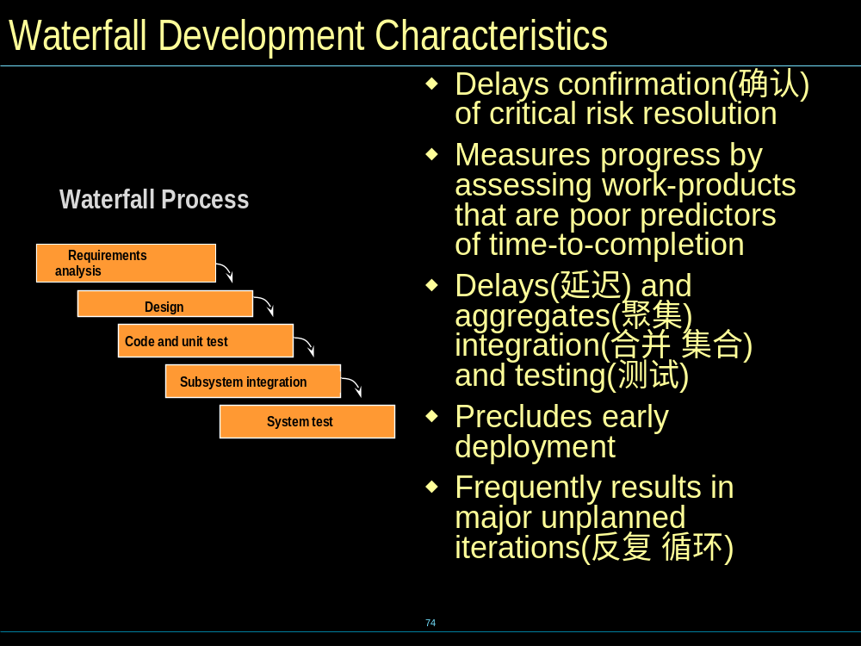
Iterative Development
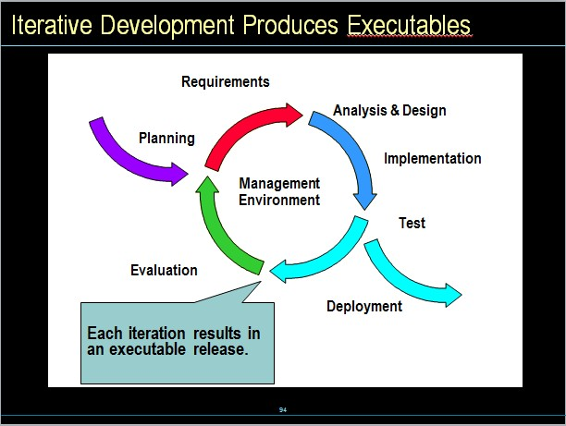

UP (Unified process)
Six Best Practices
- Develop Iteratively
- Manage Requirements
- Use Component Architectures
- Model Visually
- Verify Quality
- Control Changes

UP Structure
- 4 phases + 9 workflows
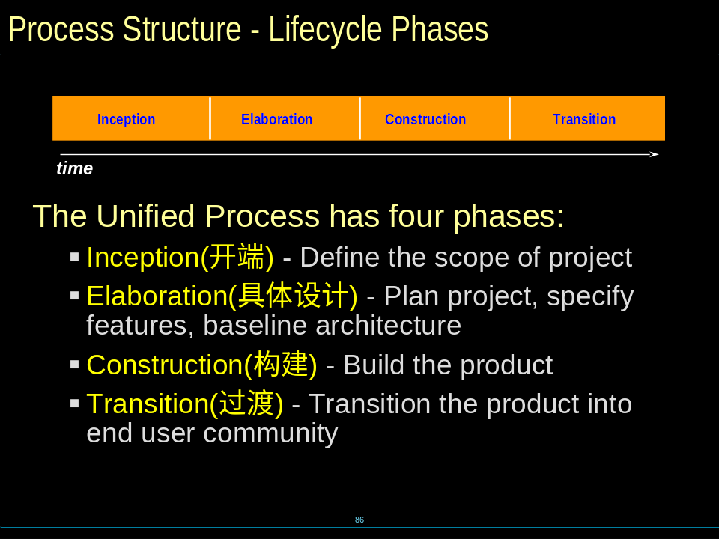

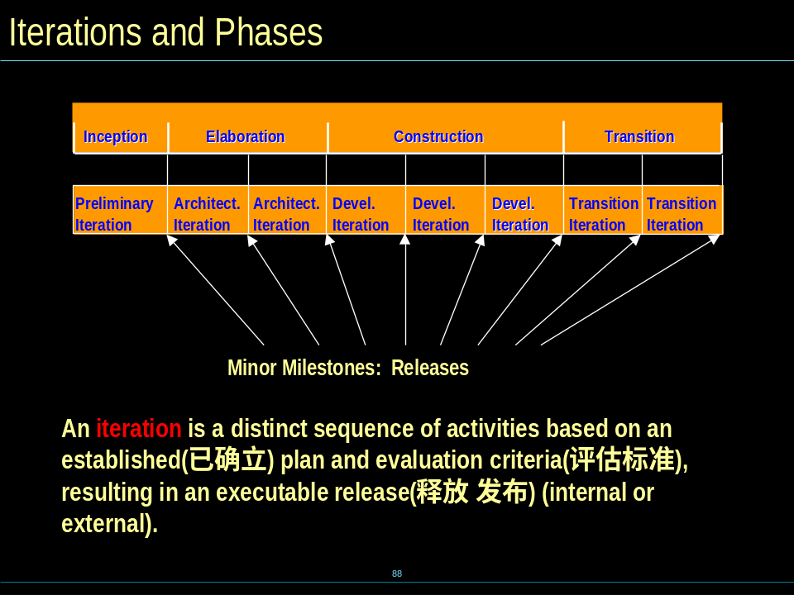

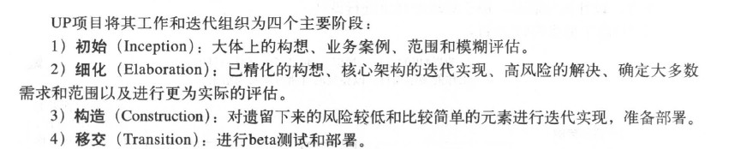

Software Architecture
- What is software Architecture?
An architectural view is a simplified description (an abstraction) of a system from a particular perspective or vantage point, covering particular concerns, and omitting entities that are not relevant to this perspective
- Architecture view (4+1 view)
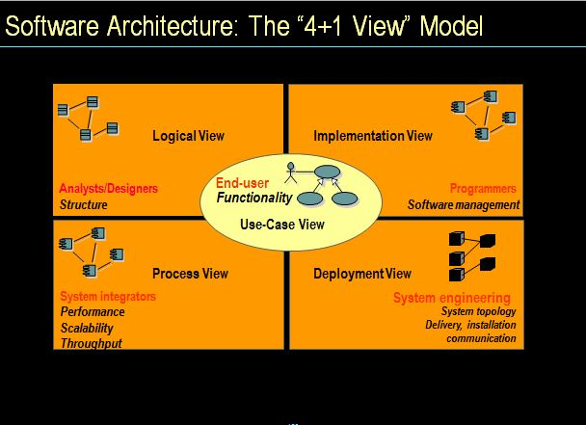

What is a pattern
- A common problem
– and a proven solution
– in a context
- A structured, packaged problem solution in literary form.
- A way of recording experience, “best practices”
– In a standard format
– A repository for knowledge
- “What’s new is that there’s nothing new here.
Patterns are about what works. Patterns give us a way to talk about what works.” – Brian Foote, 1997.

Architectural Pattern (example)
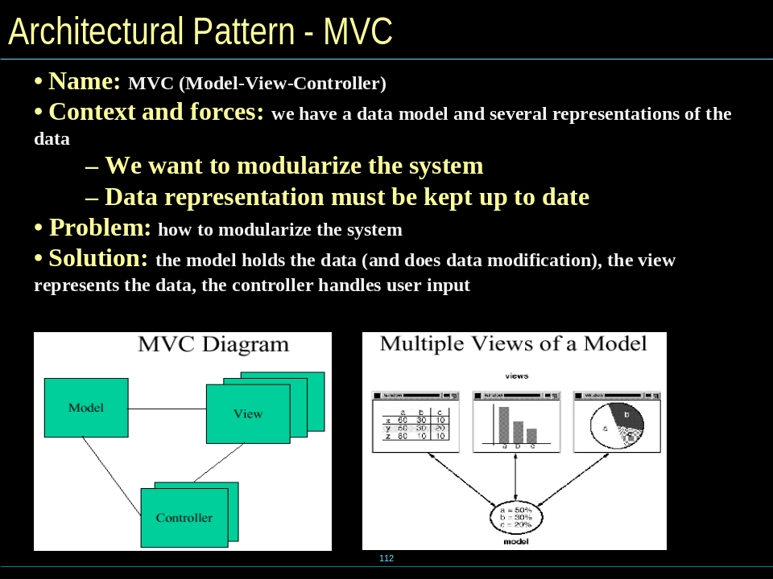

Design Pattern (example)
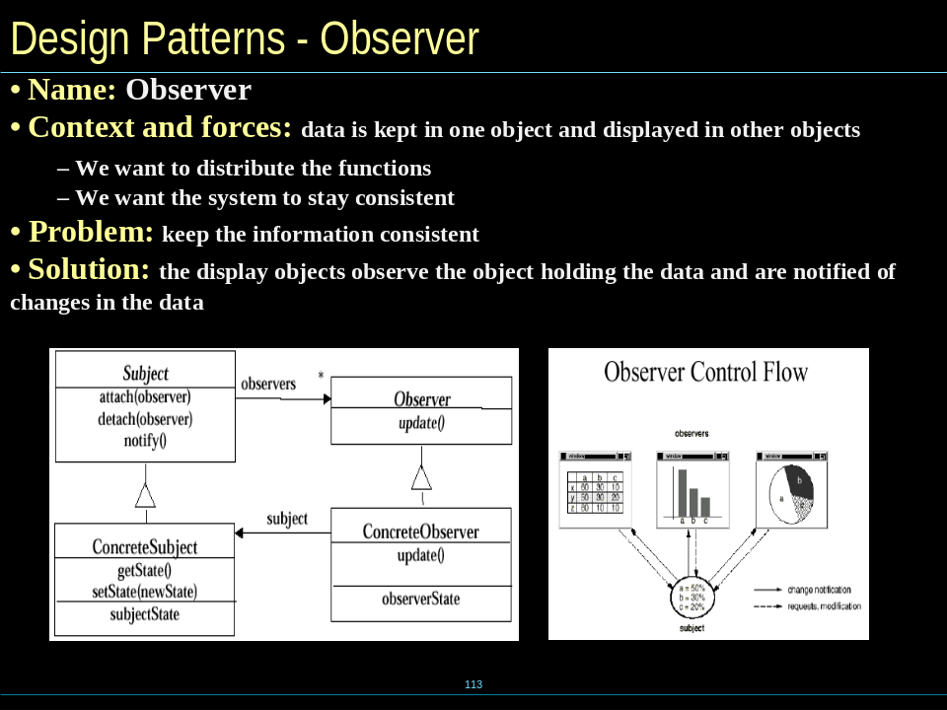

What is software Architecture?
- Software architecture encompasses the set of significant decisions about the organization of a software system
  - Selection of the structural elements and their interfaces by which a system is composed
  - Behavior as specified in collaborations among those elements
  - Composition of these structural and behavioral elements into larger subsystems
  - Architectural style that guides this organization
- Software architecture also involves
  - usage
  - functionality
  - performance
  - resilience
  - reuse
  - Comprehensibility (可了解)
  - economic and technology constraints and tradeoffs(平衡)
  - Aesthetic(美观) concerns

Architecture view
- An architectural view is a simplified description (an abstraction) of a system from a particular perspective or vantage point, covering particular concerns, and omitting(省略) entities that are not relevant to this perspective

——CH2
What is UML
- Building Blocks of the UML
  - 1) Things in the UML
  - 2) Relationships in the UML
  - 3) Diagrams in the UML
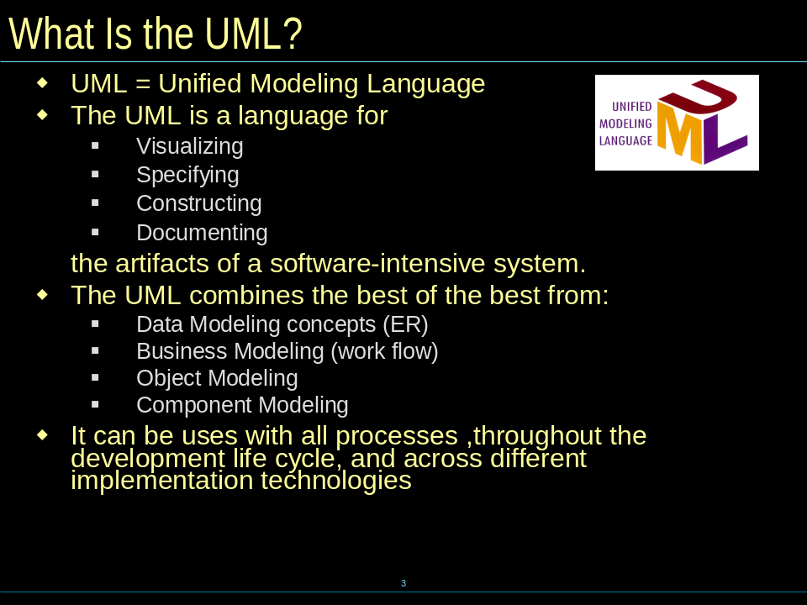

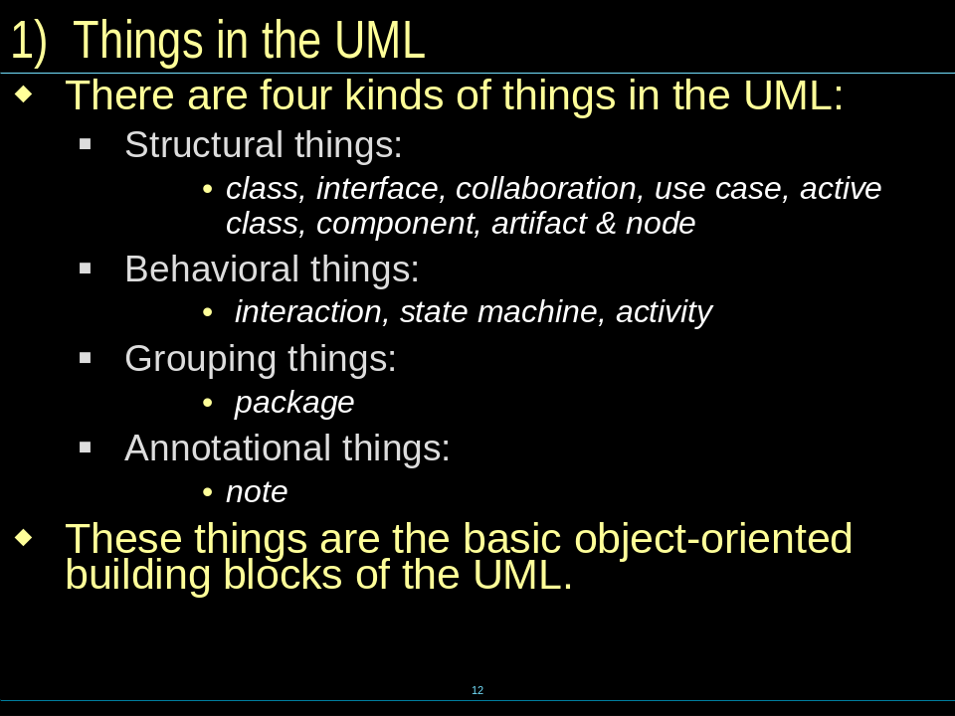
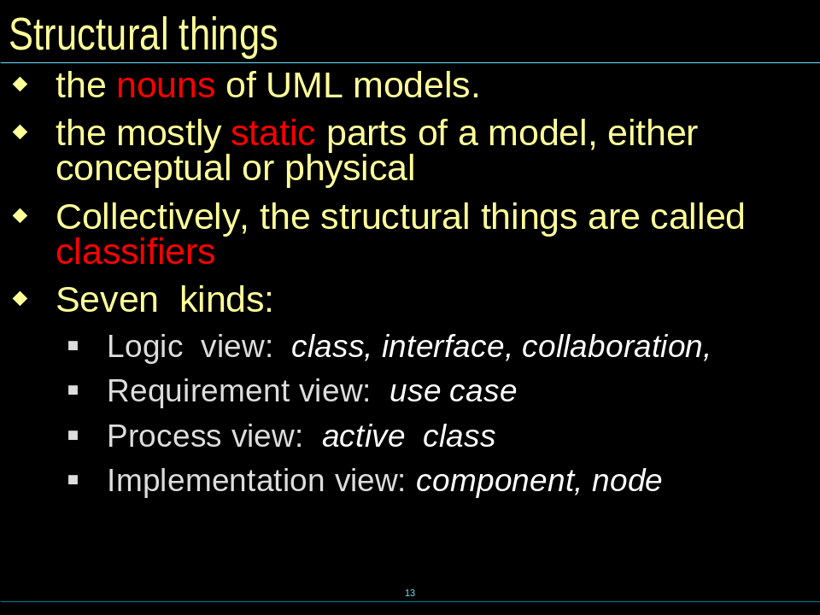

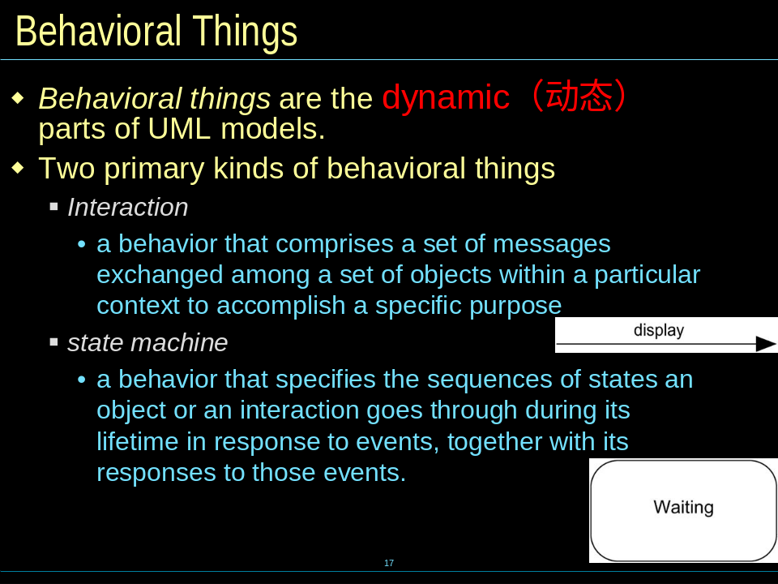

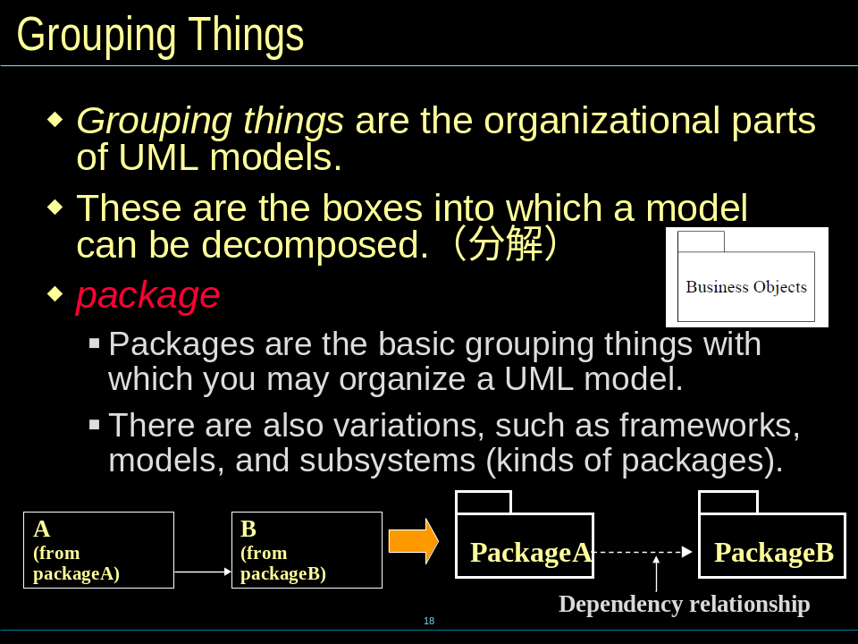

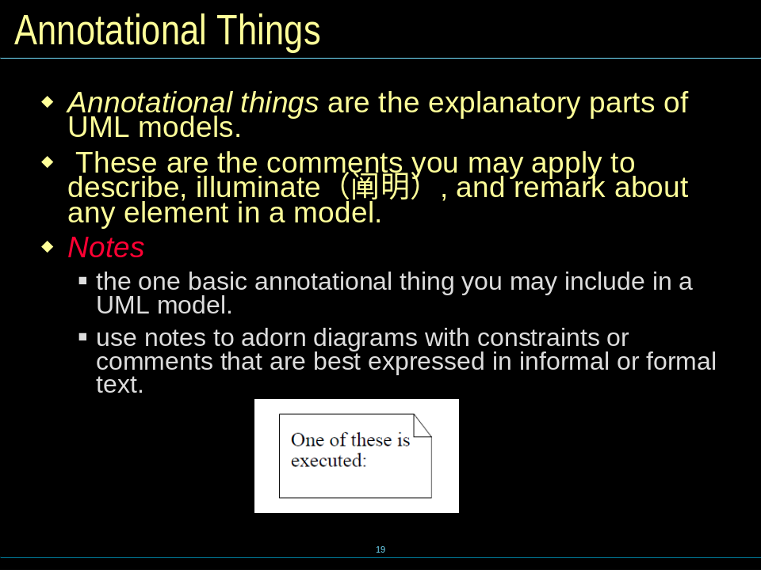

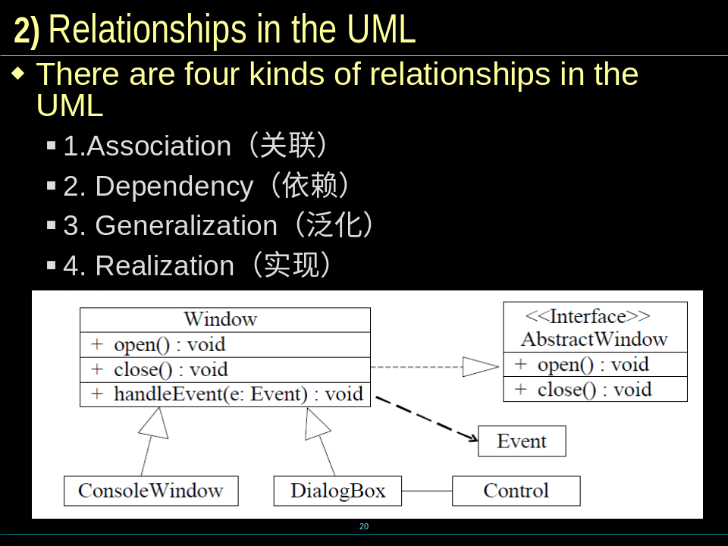

- An association is a structual relationship that describes a set of links, a link being a connection among objects
- An dependency is a semantic relationship between two things in which a change to one thing (the independent thing) may affect the semantics of the other things (the dependent thing )
- A generalization is a specialization/generalization relationship in which object of the specialized element (the child) are substitutable(可替代) for objects of the generalized element (the parent).
- A realization is a semantic relationship between classifiers, wherein one classifier specifies a contract that another classifier guarantees to carry out

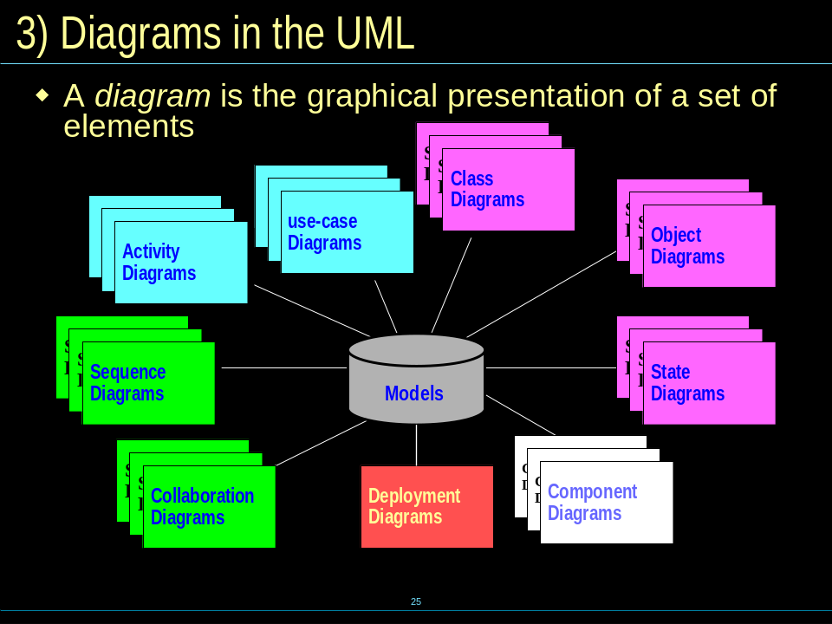

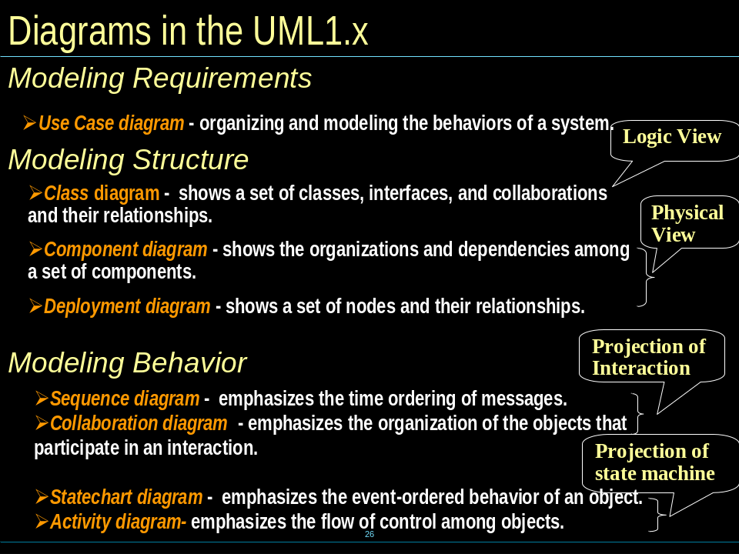

Extension mechanism(拓展结构？)
-Stereotype(衍型)
- A stereotype is an extension of the vocabulary of the UML, allowing you to create new kinds of building blocks similar to existing ones but specific to your problem.
- Stereotypes must be based on certain existing types or classes in the metamodel. Stereotypes may extend the semantics, but not the structure of pre-existing types and classes.
- Certain stereotypes are predefined in the UML, others may be user defined.
- Stereotypes define a new model element in terms of another model element.
- Sometimes, you need to introduce new things that speak the language of your domain and look like primitive building blocks.
- Represented with name in guillemets or as a different icon

-Tagged value(标签)
- A tagged value is an extension of the properties of a UML element, allowing you to create new information in that element’s specification.
- A tagged value is a keyword-value pair that may be attached to any kind of model element The keyword is called a tag.

-Constraint(约束)
- A constraint is an extension of the semantics of a UML elements, allowing you to add new rules or to modify existing ones.
- Constraints may be written as free-form text. If you want to specify your semantics more precisely, you can use the UML’s Object Constraint Language(OCL).
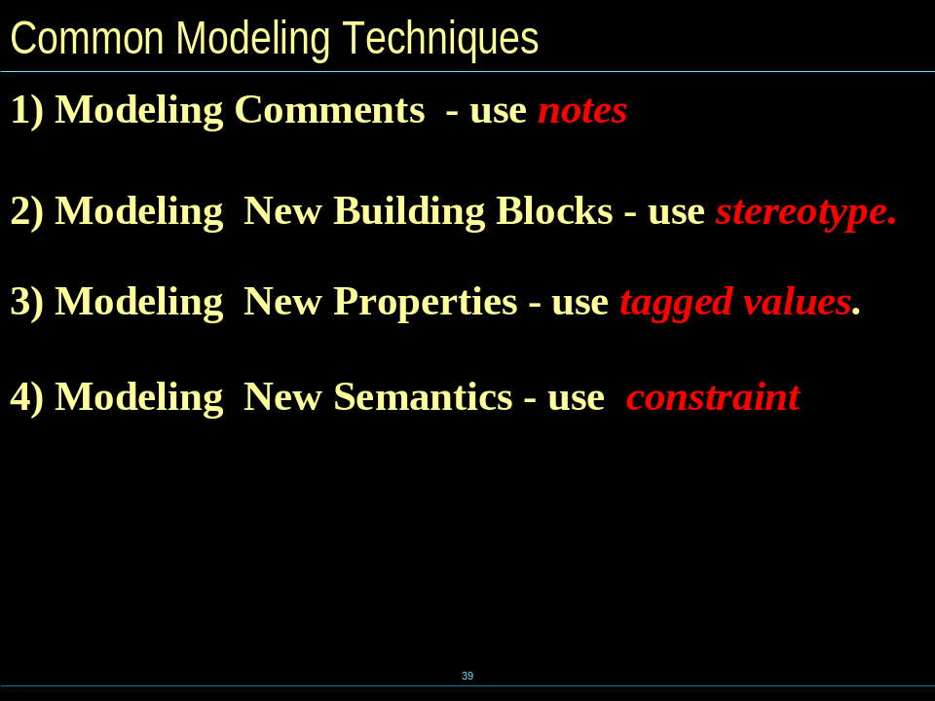
- Actor & Use Case
Actors represent roles a user of the system can play.
  - They can represent a human, a machine, or another system.
  - Actors are not part of the system.
  - Actors are EXTERNAL
A use case is a description of set of sequence of actions that a system performs that yields an observable result of value to a particular actor
  - A use case is initiated by an actor to invoke a certain functionality in the system.
  - A use case is realized by a collaboration
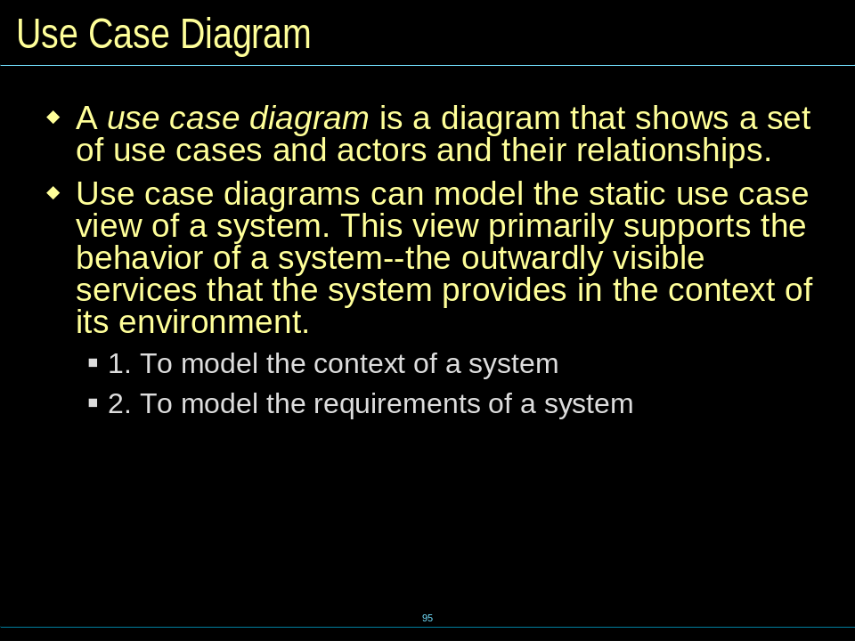
<其余见后>

Interaction Diagram（协作图）
- An interaction diagram shows an interaction, consisting of a set of objects and their relationships, including the messages that may be dispatched among them.
- It models the dynamic aspects of a system.
  - Modeling flows of control by time ordering
  - Modeling flows of control by organization

-Sequence diagrams (*) （顺序图）
link, message, sequencing, object lifeline, focus of control
- A link is a semantic connection among objects. In general, a link is an instance of an association
- A message is a specification of a communication between objects that conveys information with the expectation that activity will ensue
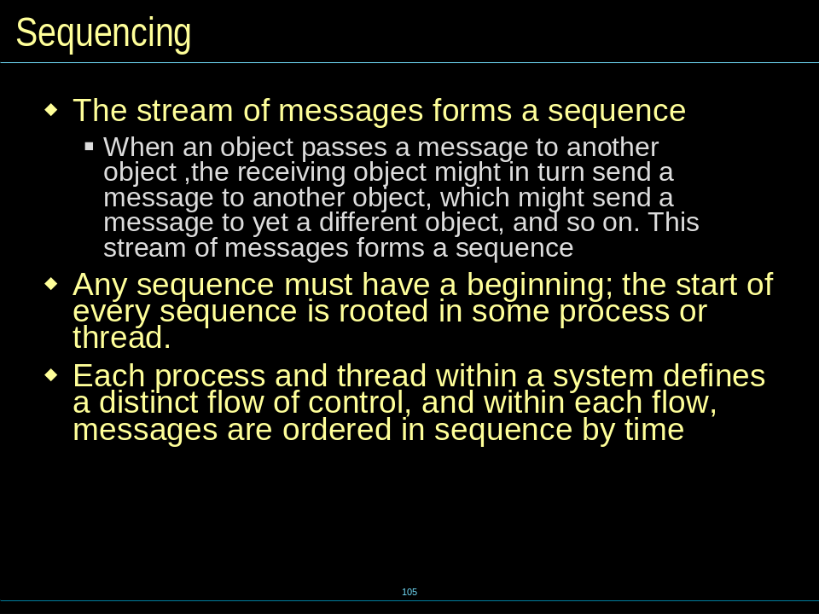

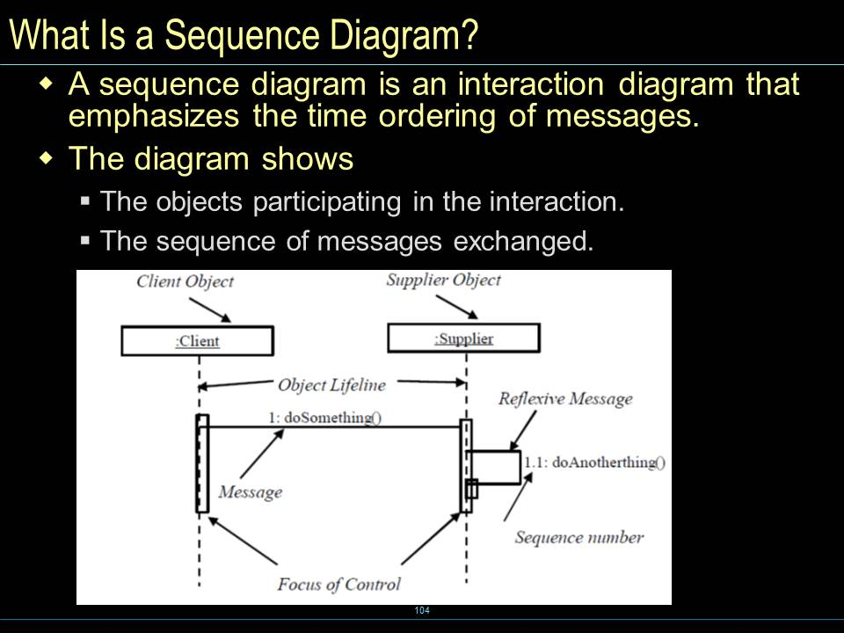
-Collaboration diagrams(协作图)
show the relationships among objects and are better for understanding all of the effects on a given object and for procedural design.

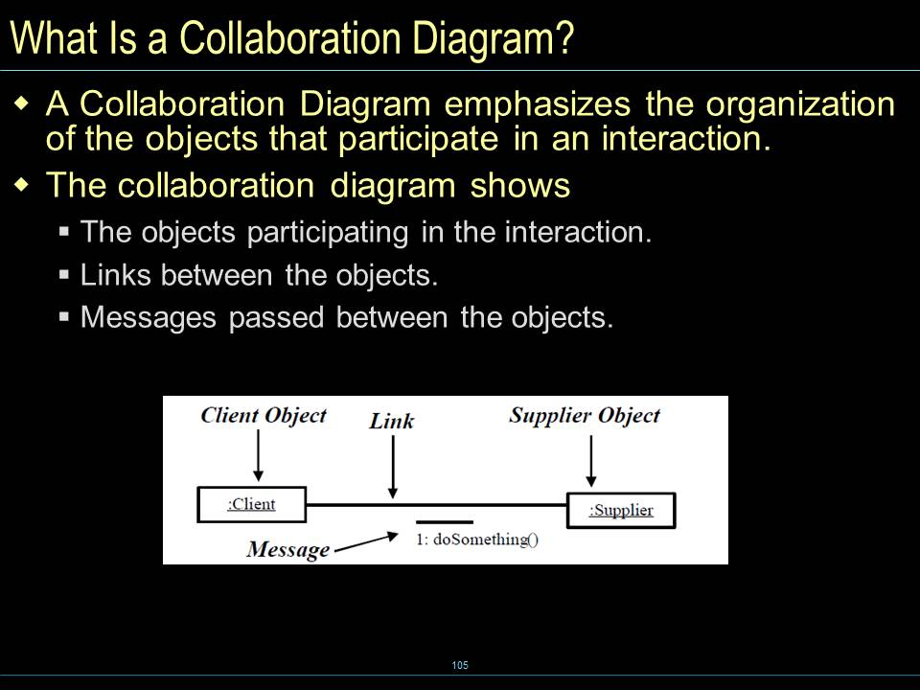

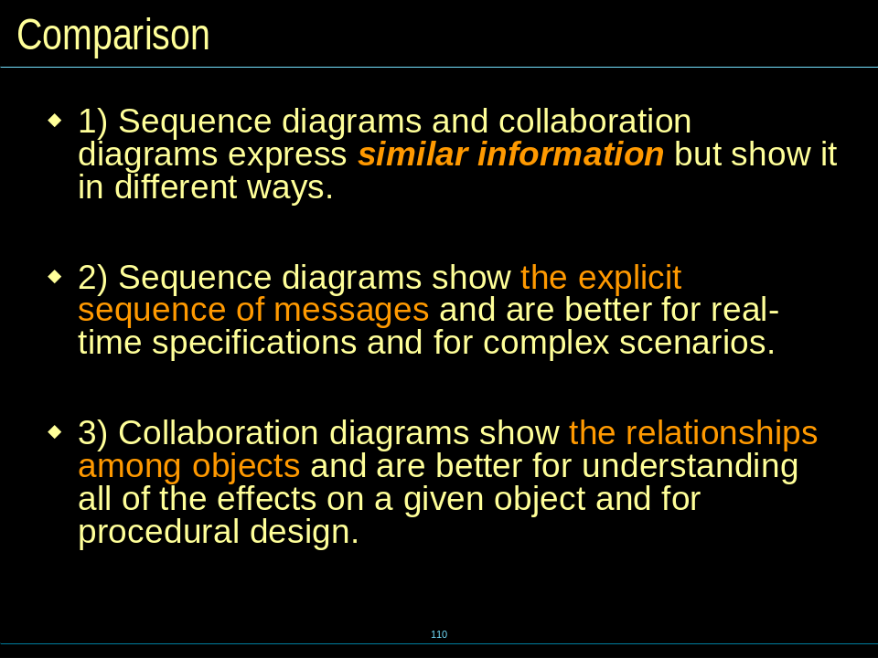

StateChart Diagram (*)（状态图）
State, transition, Substate, History States
- A state is a condition or situation during the life of an object during which it satisfies some condition, performs some activity, or waits for some event
- A transition is a relationship between two states indicating that an object in the first state will perform certain actions and enter the second state when a specified event occurs and specified conditions are satisfied.
- A substate is a state that's nested inside another one, which can help us simplify the modeling of complex behaviors
A history state allows a composite state that contains sequential substates to remember the last substate that was active in it prior to the transition from the composite state.

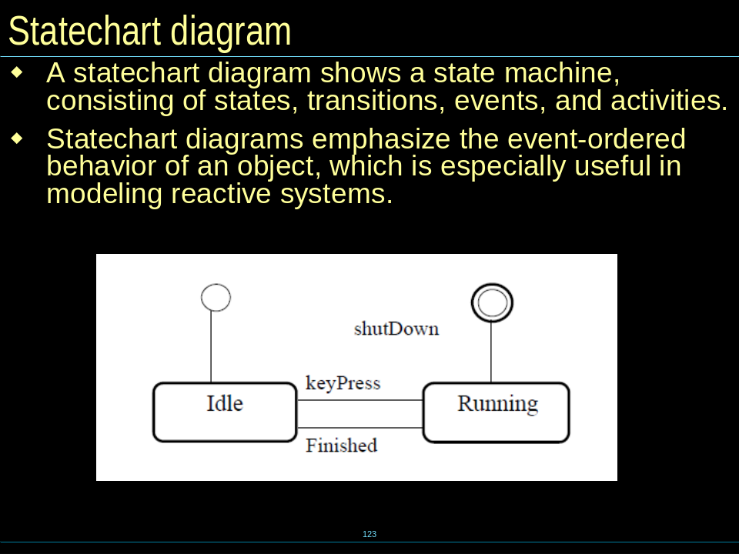

Activity Diagram（活动图）
Activity , Decisions, guard conditions ,synchronization bar
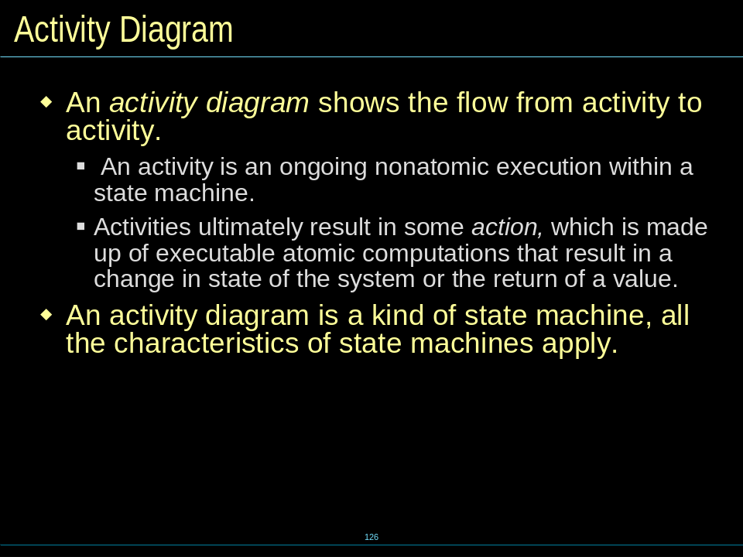

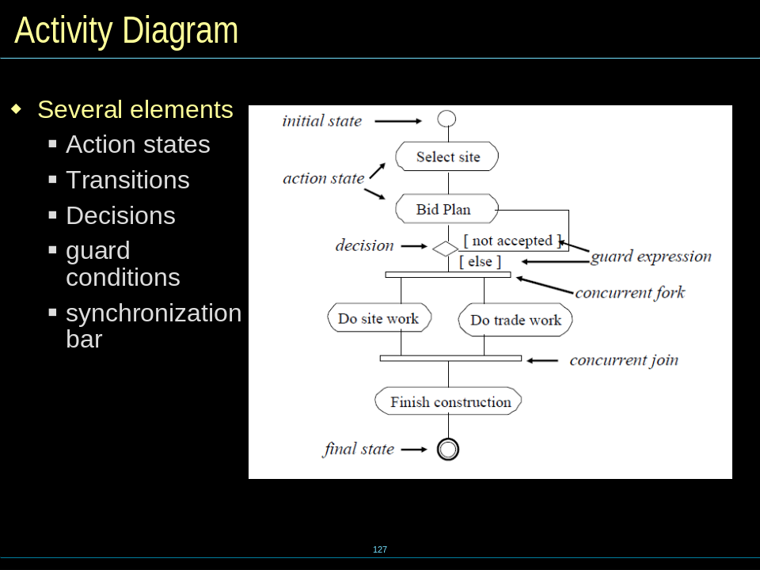
(泳道)
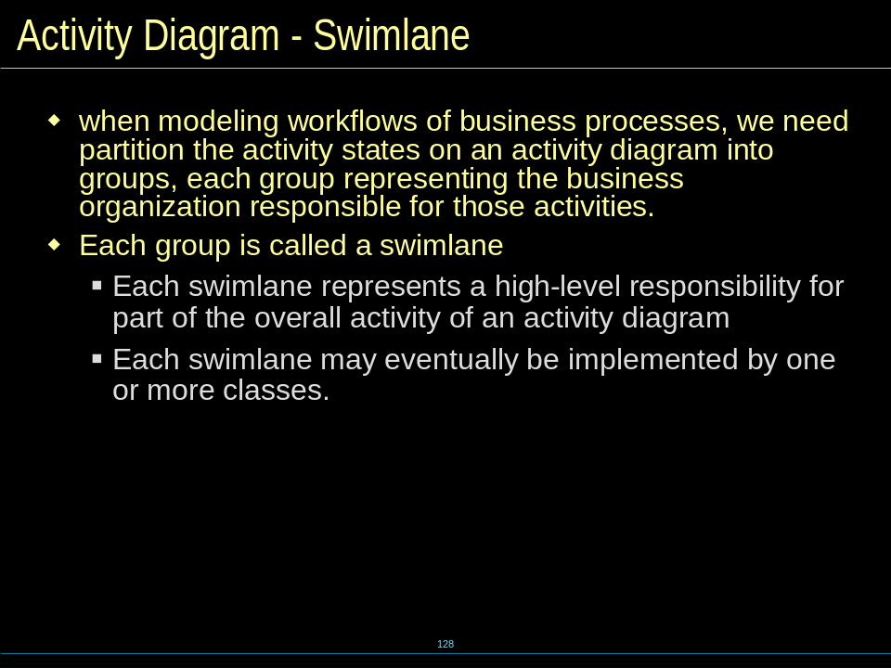
Deployment Diagram（部署图）
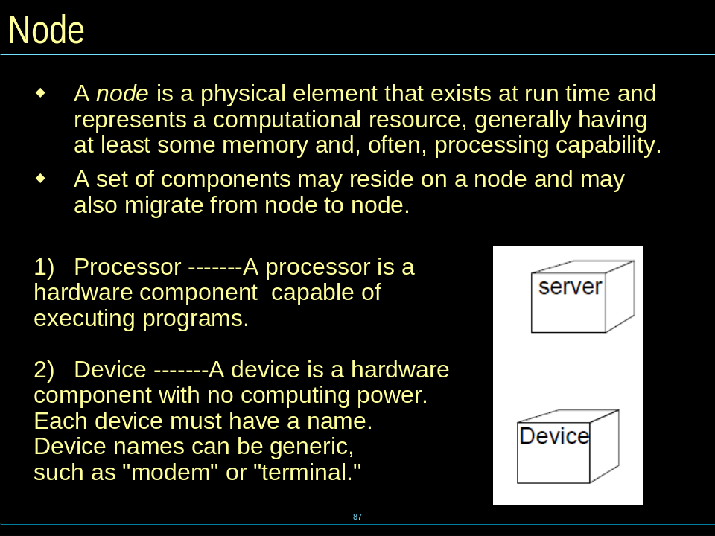

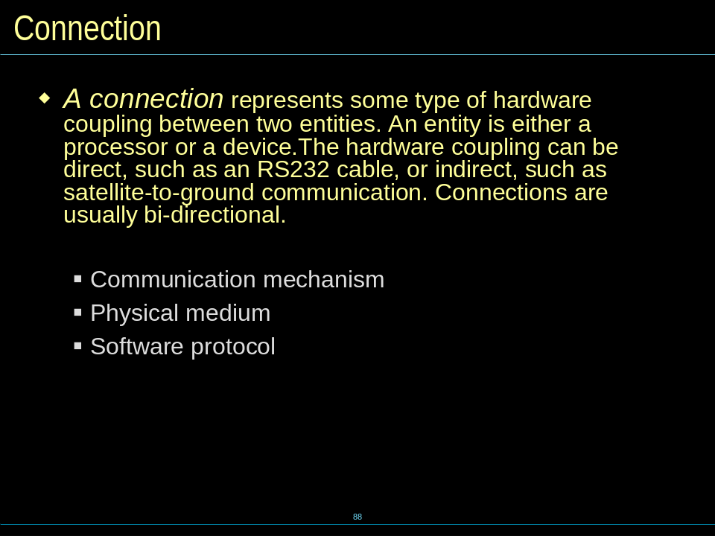

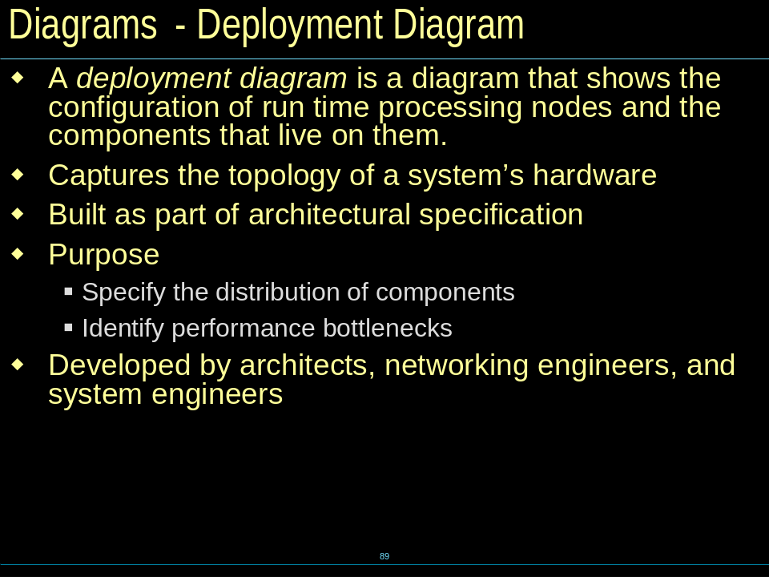

Component Diagram(构件图)
- A component is a physical and replaceable part of a system that conforms to and provides the realization of a set of interfaces, such as COM+,JavaBean
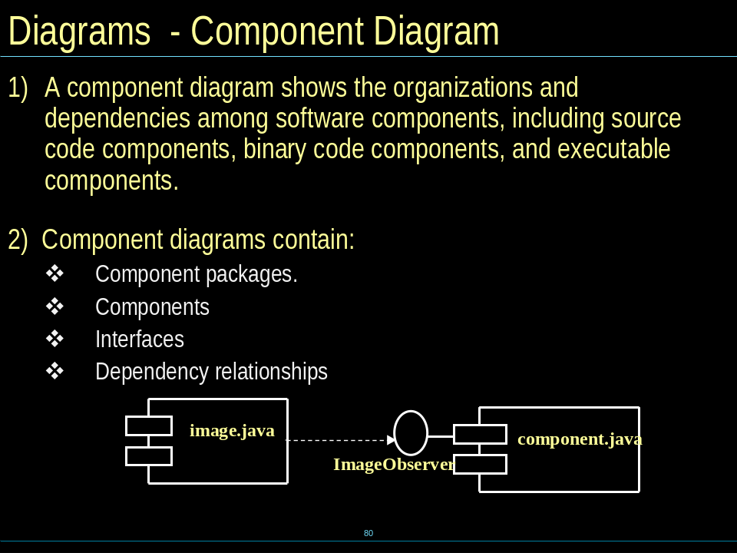

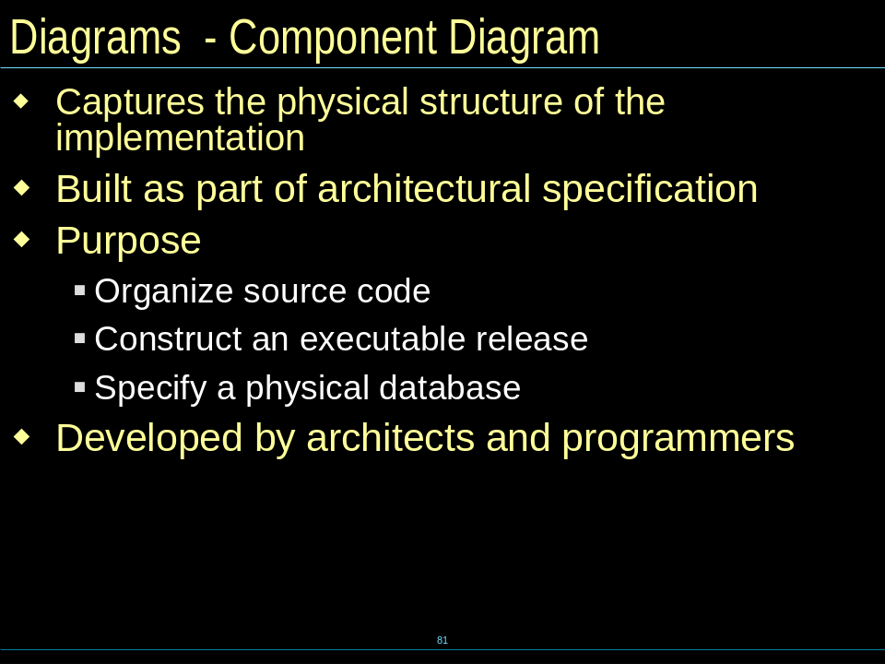

Class Diagram (*)（类图）
- A class is a description of a set of objects that share the same attributes, operations, relationships, and semantics.
- A class is represented using a compartmented rectangle
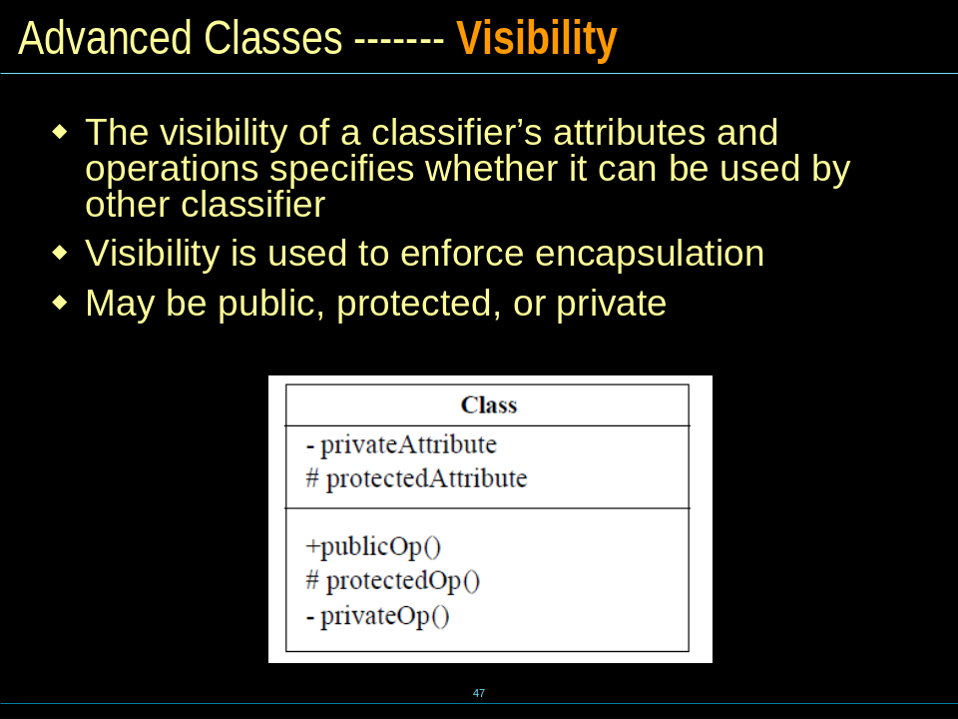

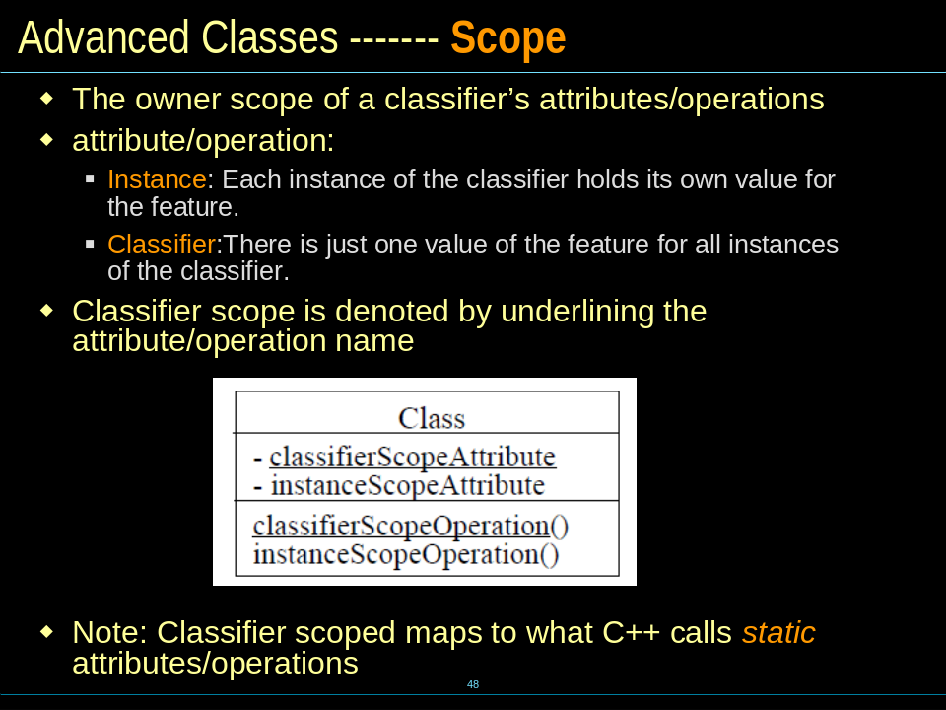

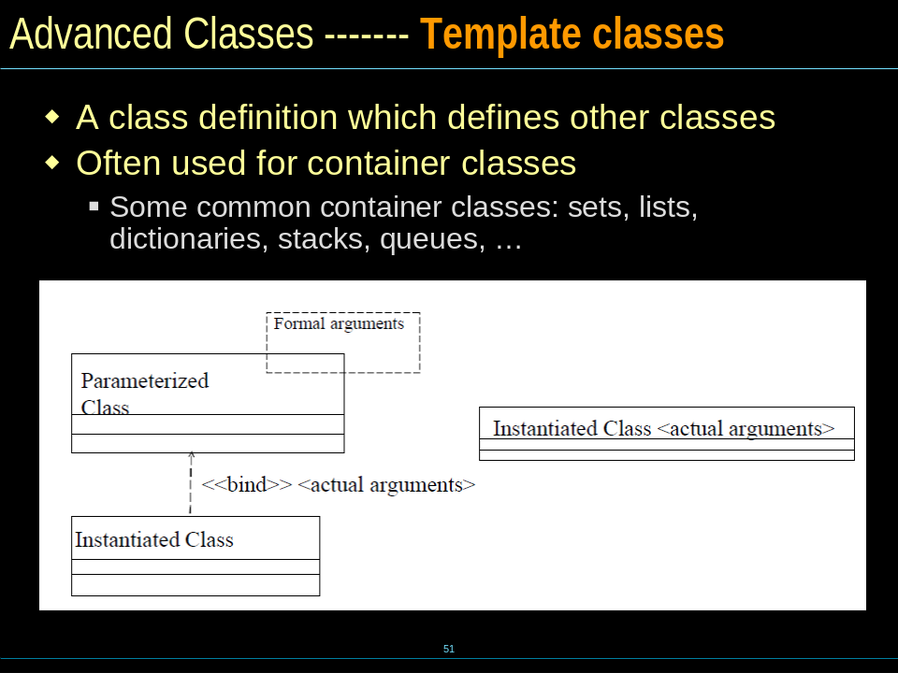

- multiplicity, navigation, Association Class
- Comparison
Associations, Aggregation(聚合), & Composition(组合)
Association(关联), Dependency(依赖) & Generalization(泛化)

——CH3
What is Requirements（需求）
- Requirements are capabilities and conditions to which the system (and more broadly, the project) must conform. [JBR99].
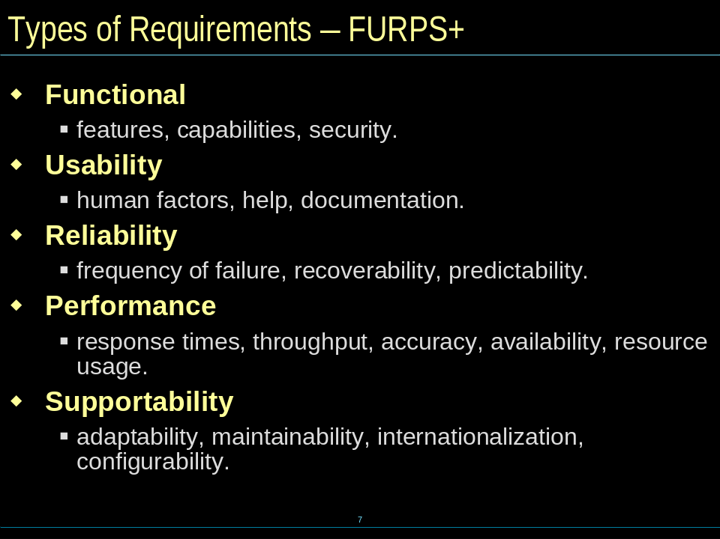

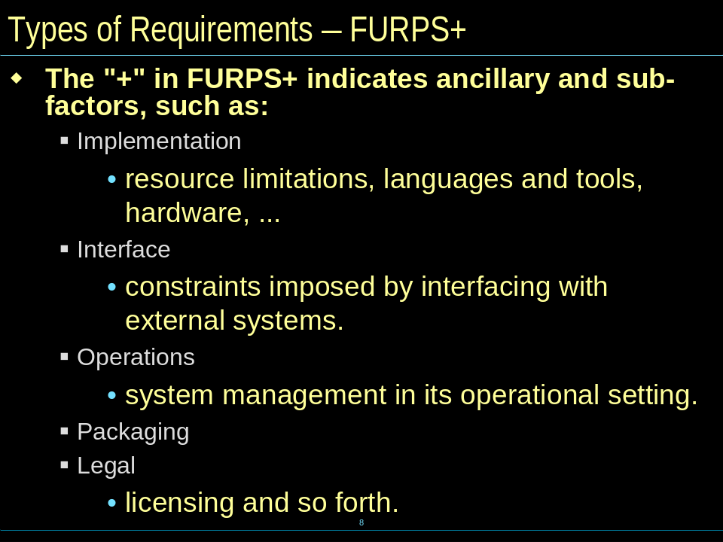

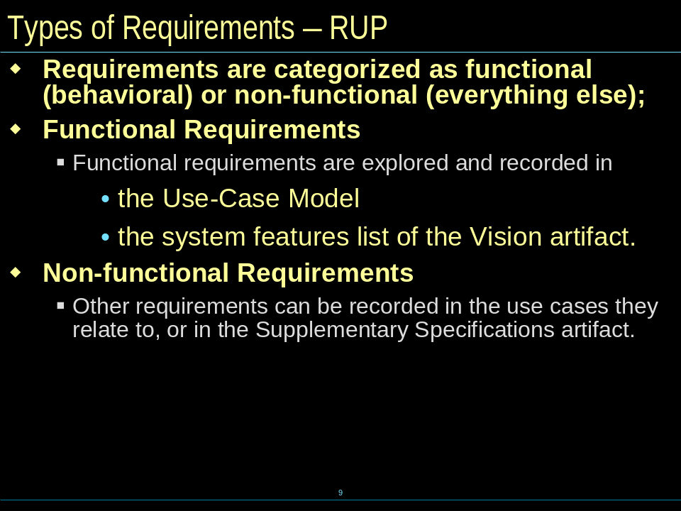

Requirements Documents
- Vision
- SRS（Software Requirement Specification,软件需求规范）
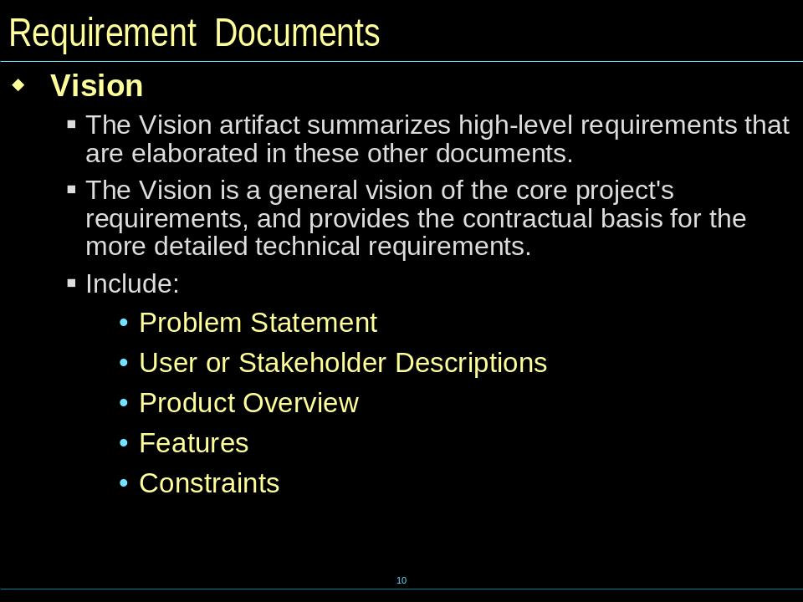

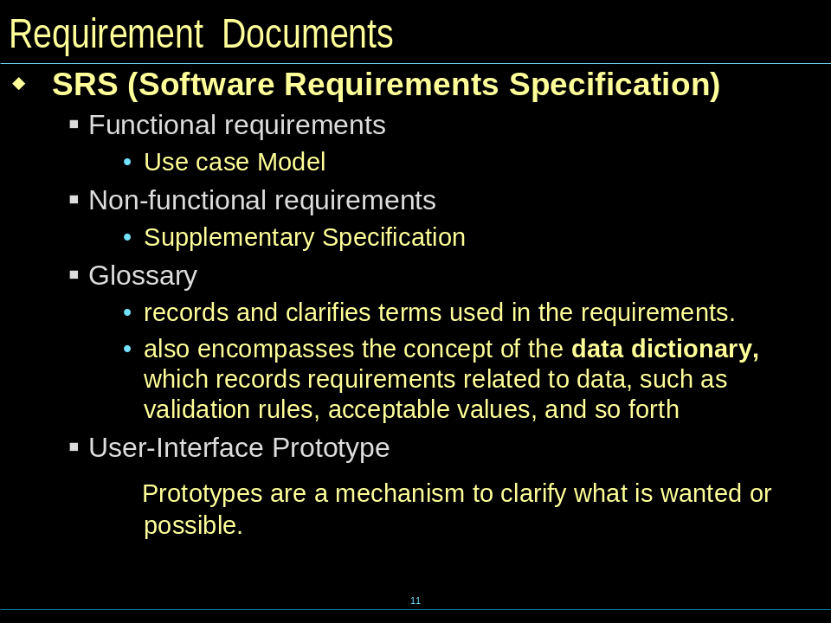

Use-Case Modeling
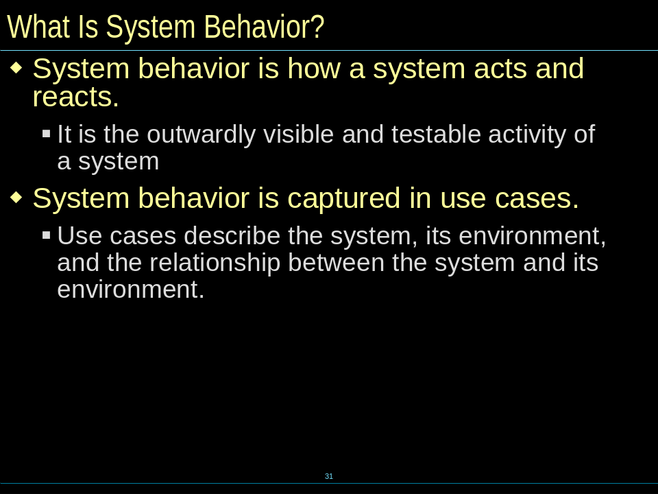

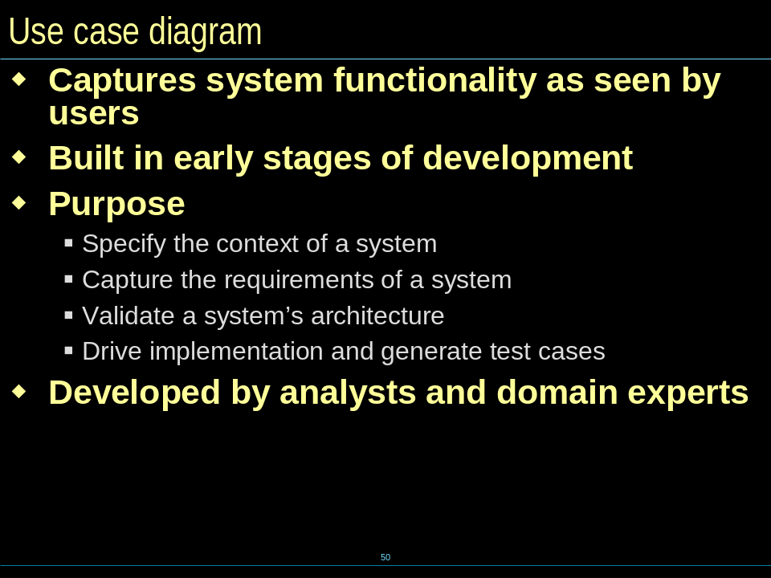

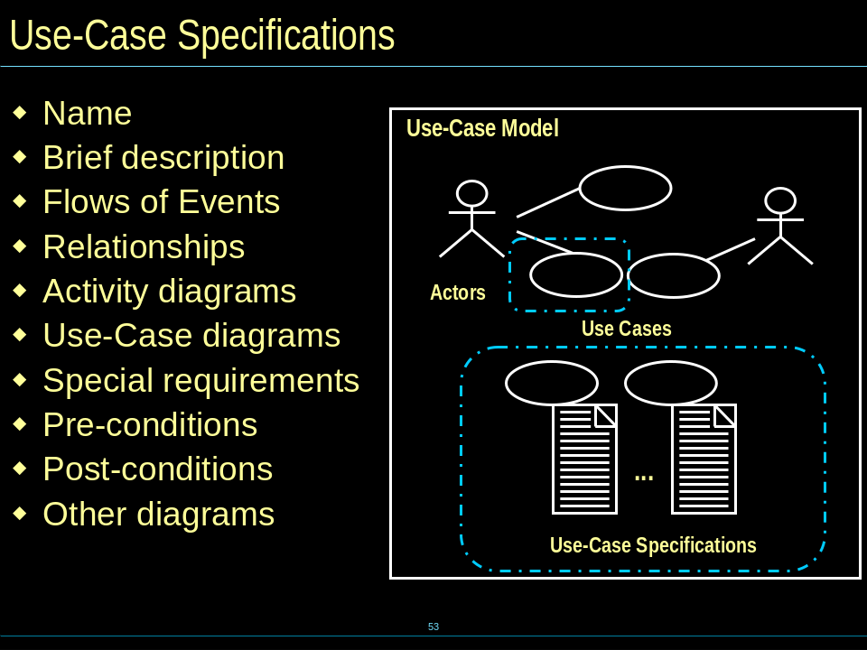

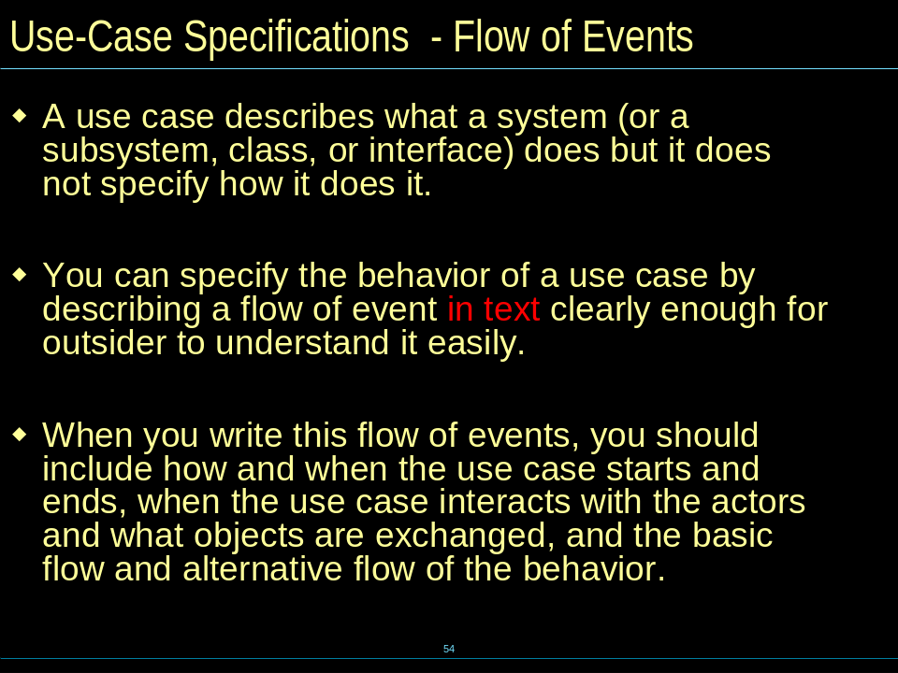

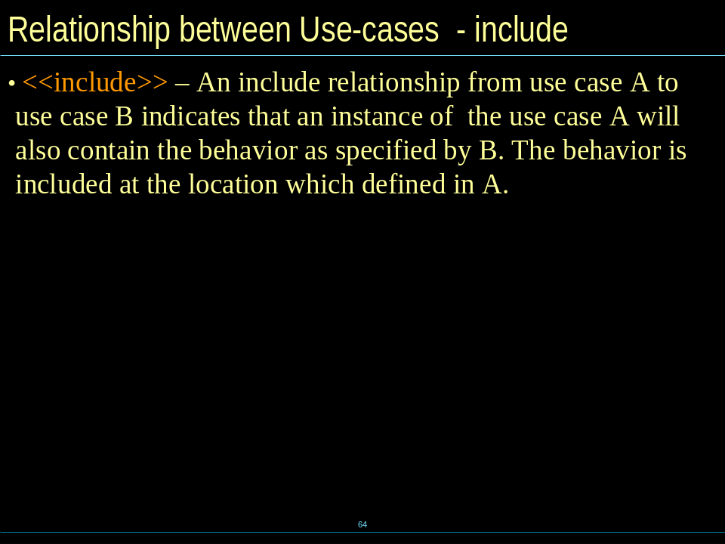

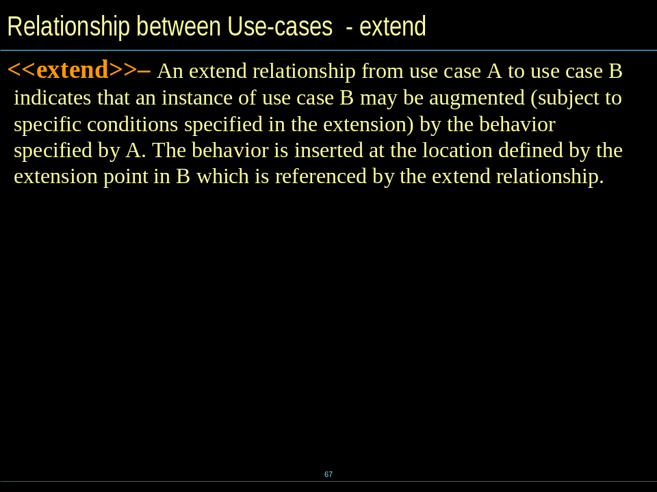

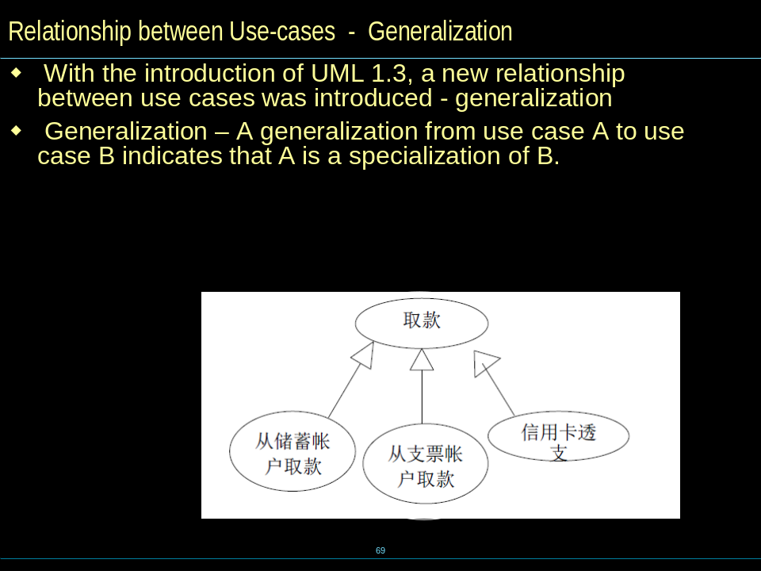

——CH4
What is OOA?
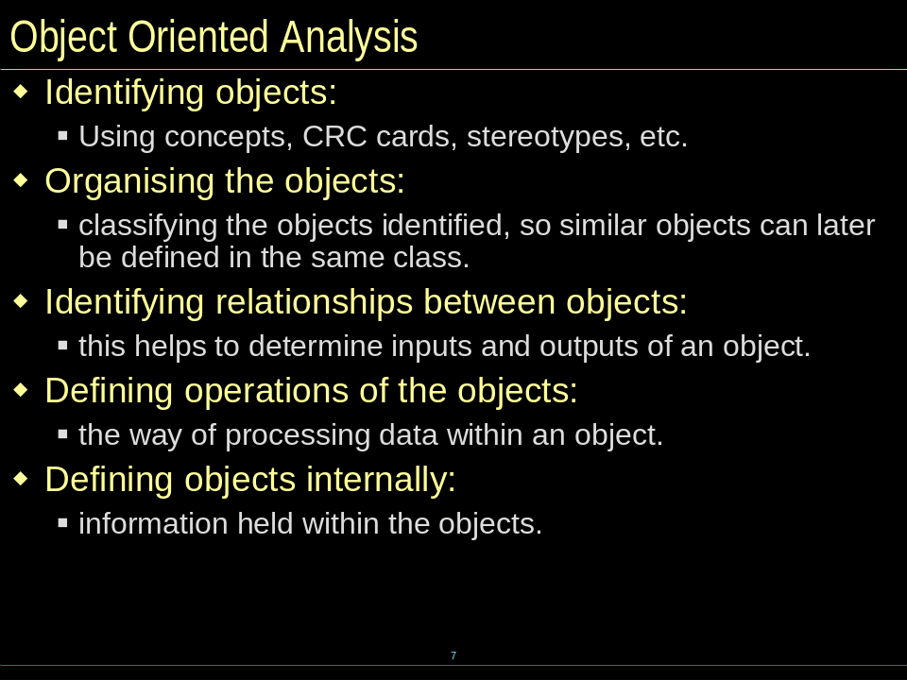

How to do Domain Modeling
- Identifying conceptual classes
- Finding Associations
- Adding Attribute
- Modeling Generalization
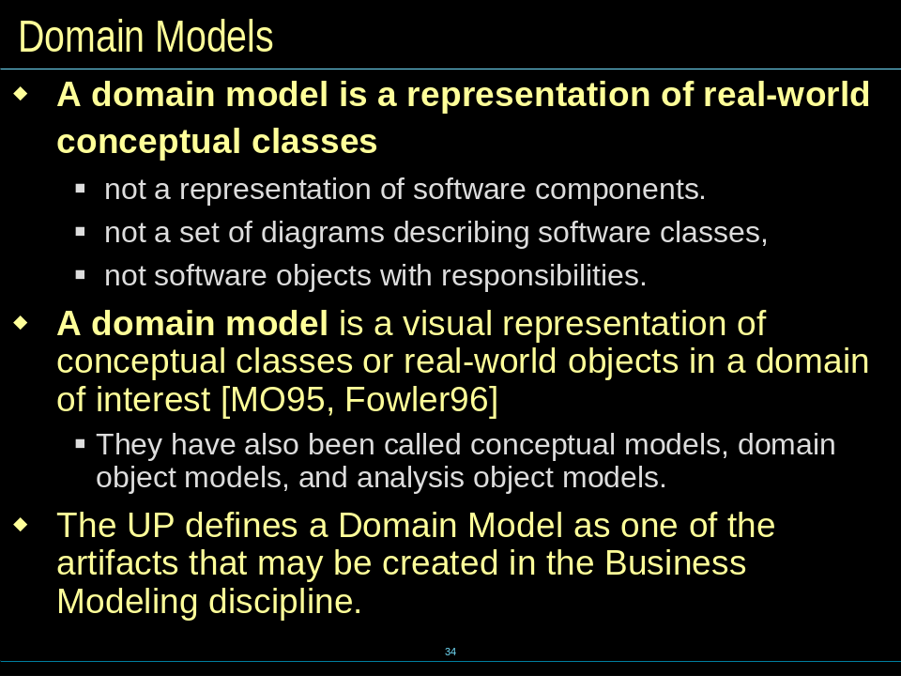
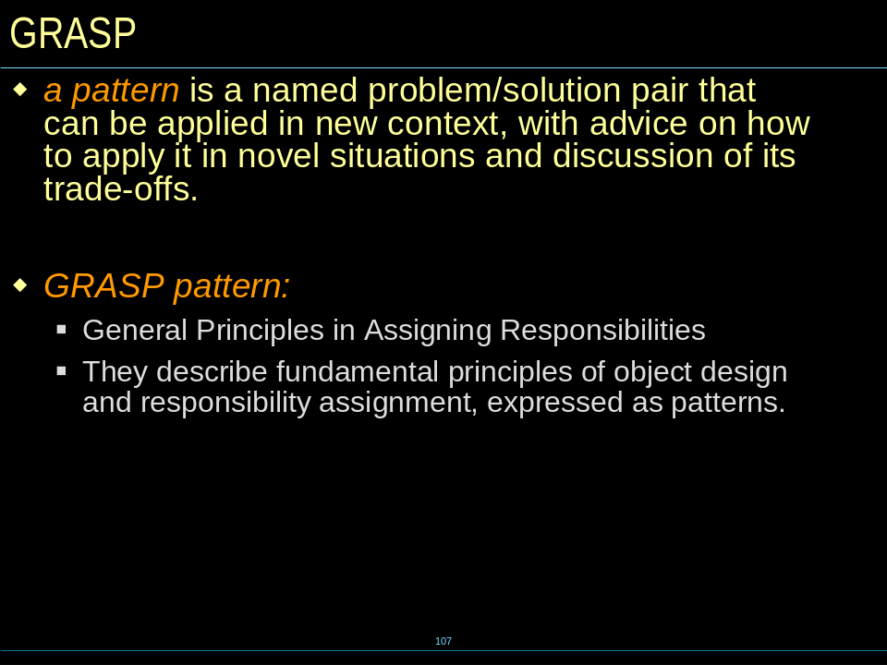

- General Principles in Assigning Responsibilities
- Nine GRASP pattern
Information Expert ,Creator, Low Coupling, High Cohesion, Controller,Polymorphism, Pure Fabrication, Indirection, Protected Variation
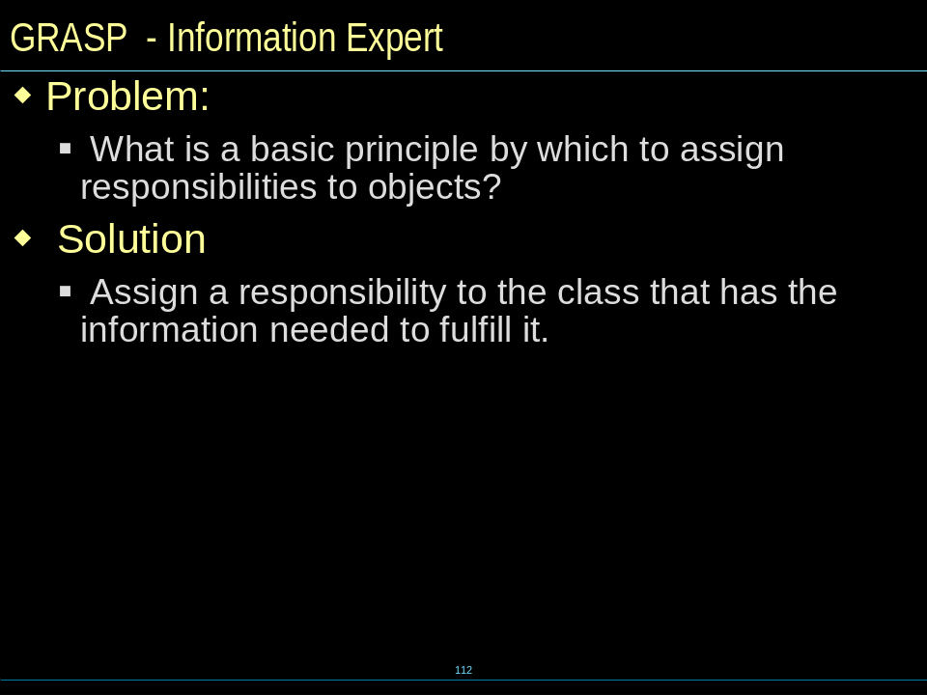

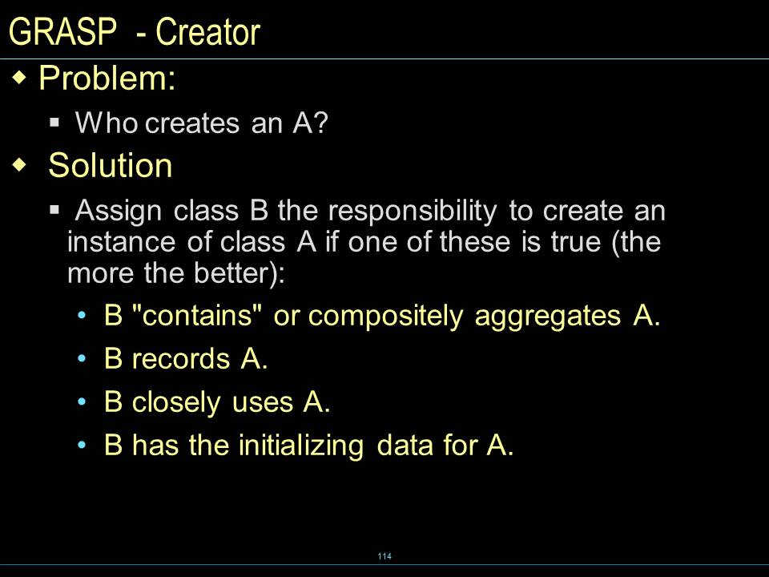

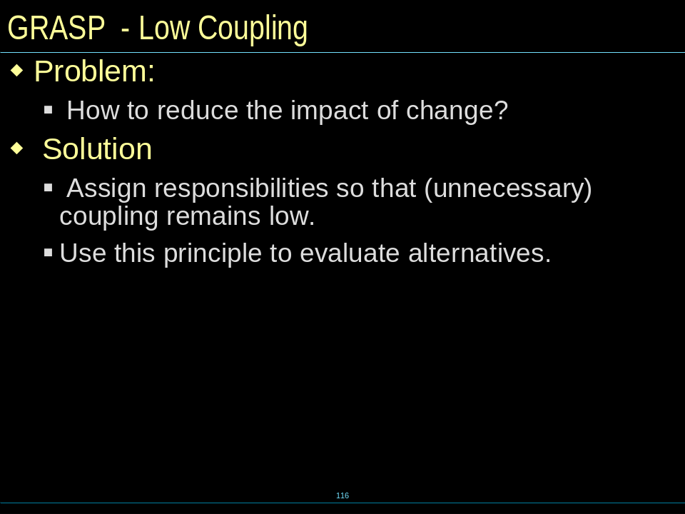

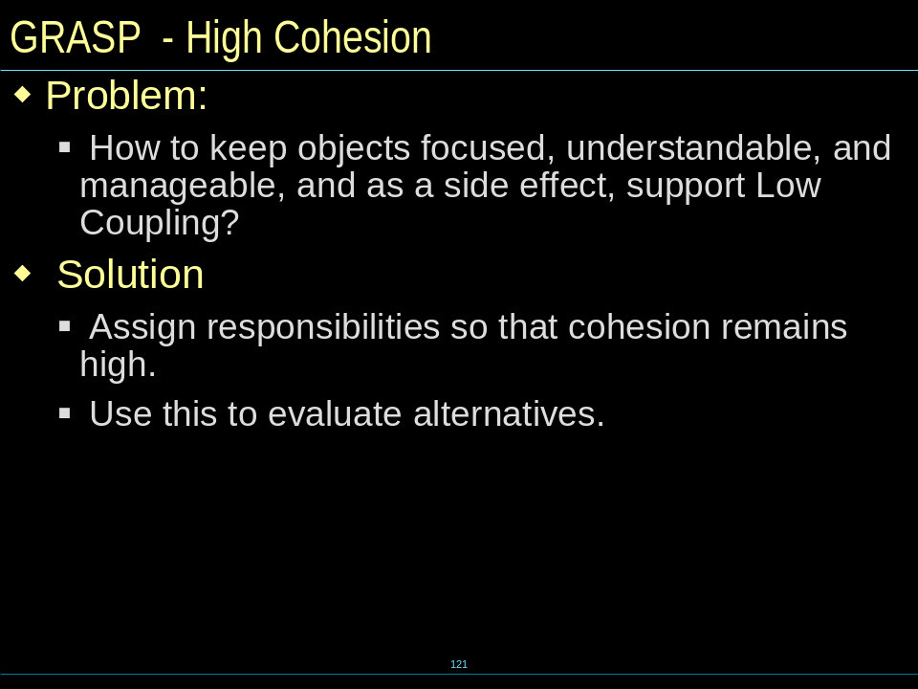

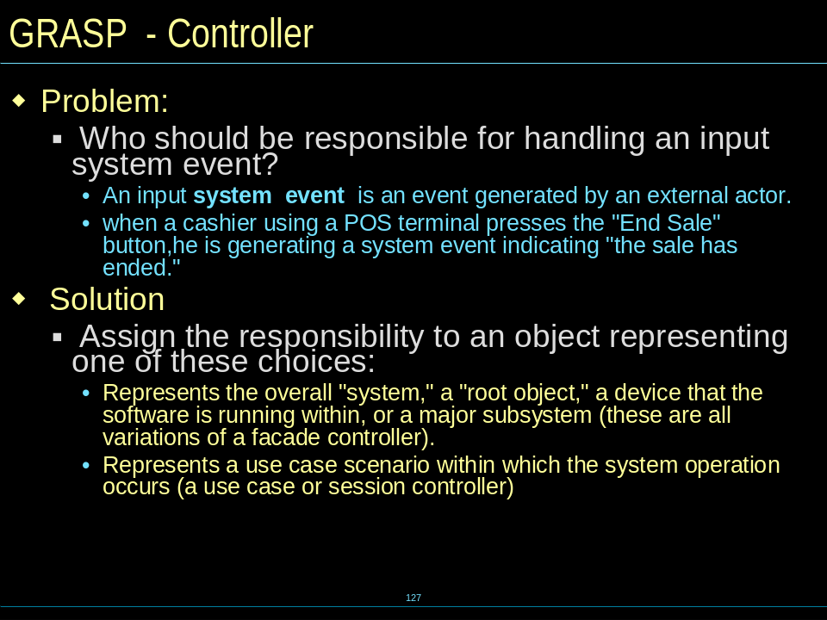

Use-Case Analysis
  - The purpose of use case Analysis
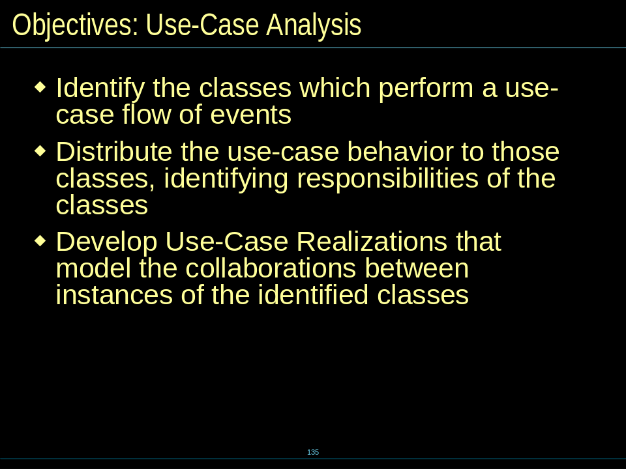

What is use case Realization?
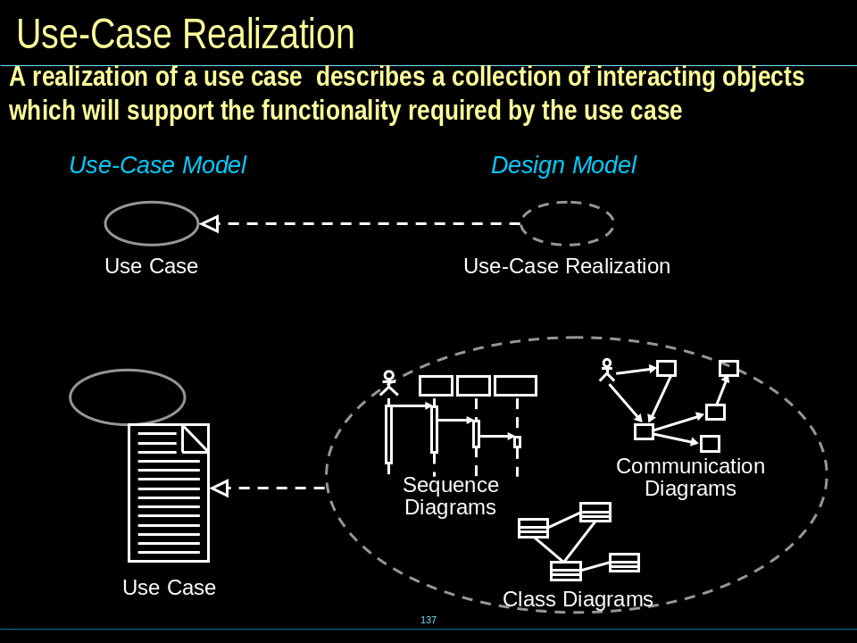

Analysis classes
- Boundary, Entity ,Control classes
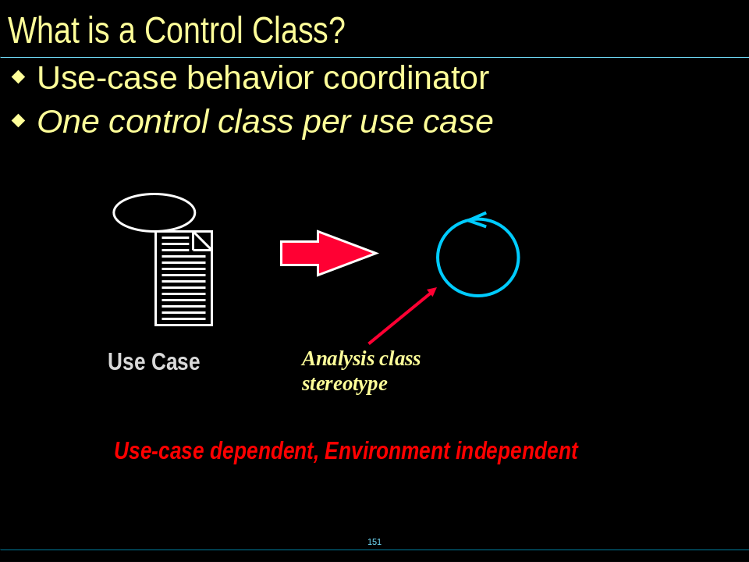

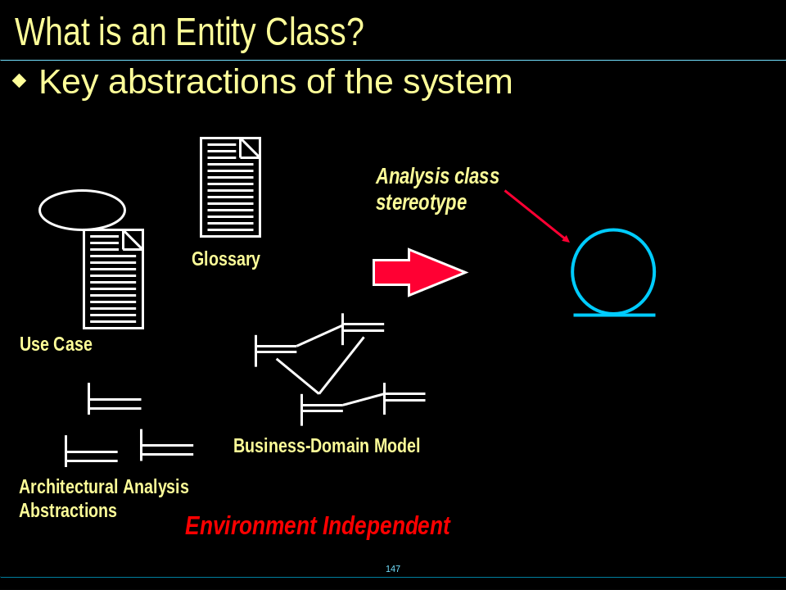

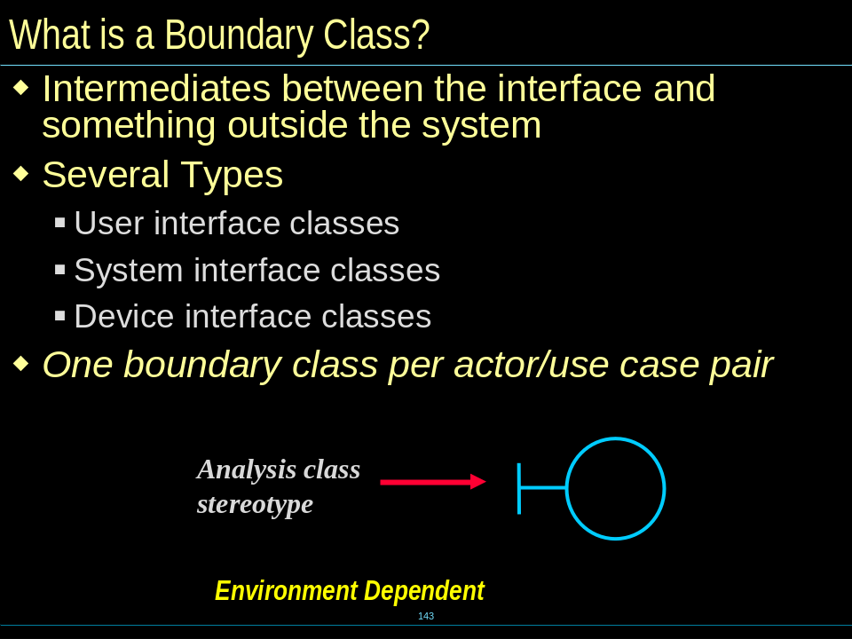
——CH5
What is OOD?
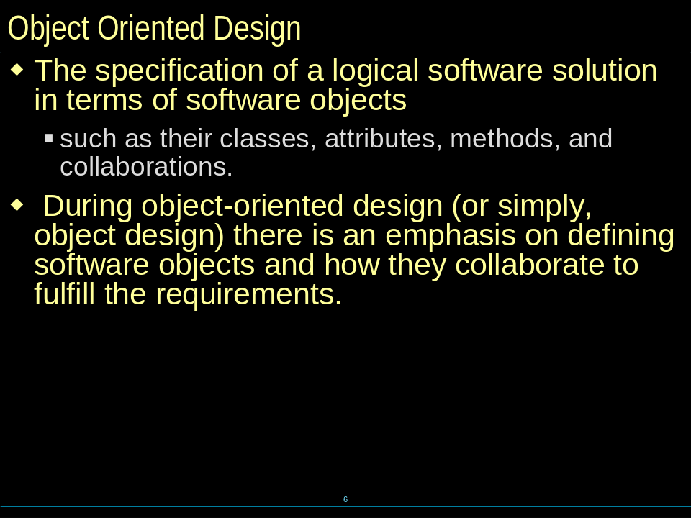

The difference between OOA & OOD
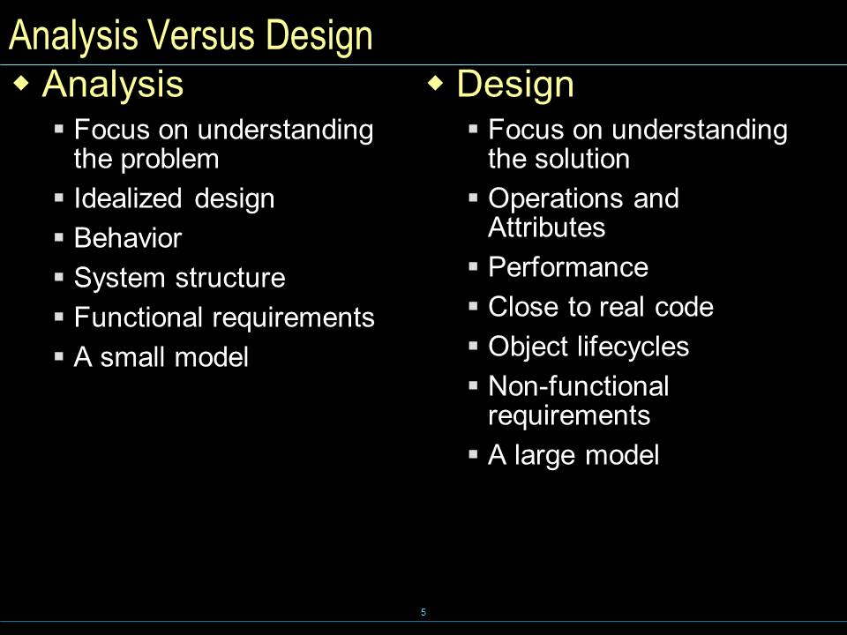

Logical Architecture
    - Typical Layering Approach (Four layer)
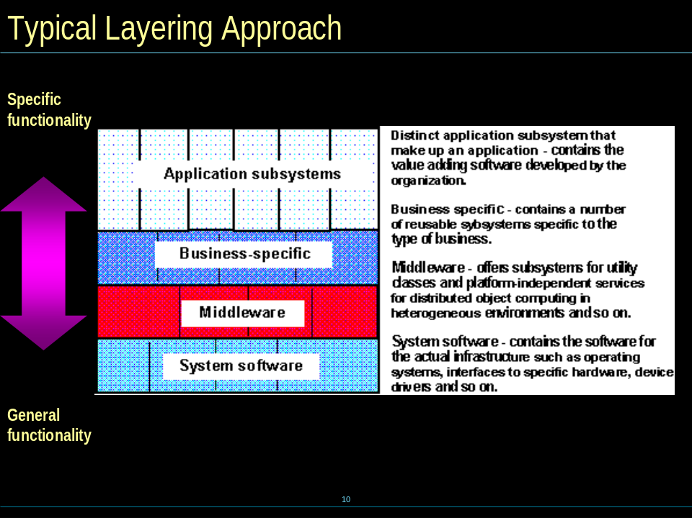

    - Tiers, Layers, and Partitions
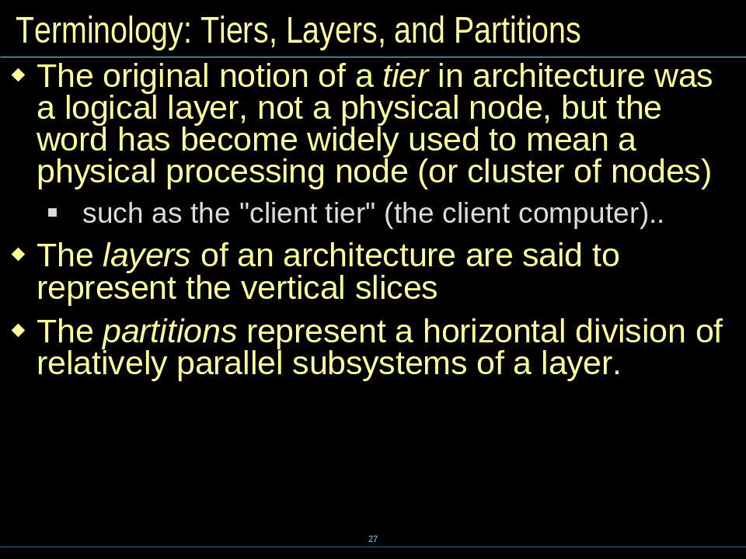

    - Packages versus Subsystems
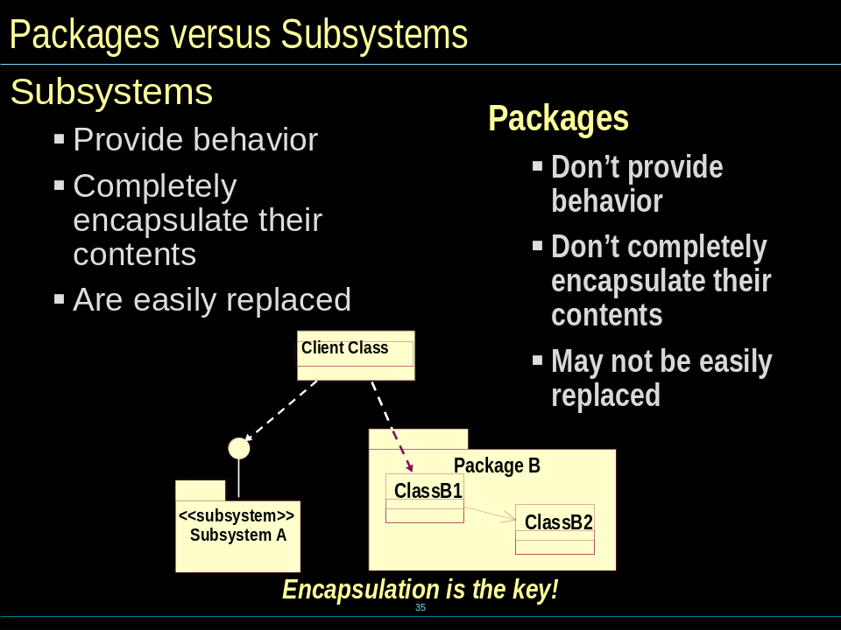

Describe run-time Architecture
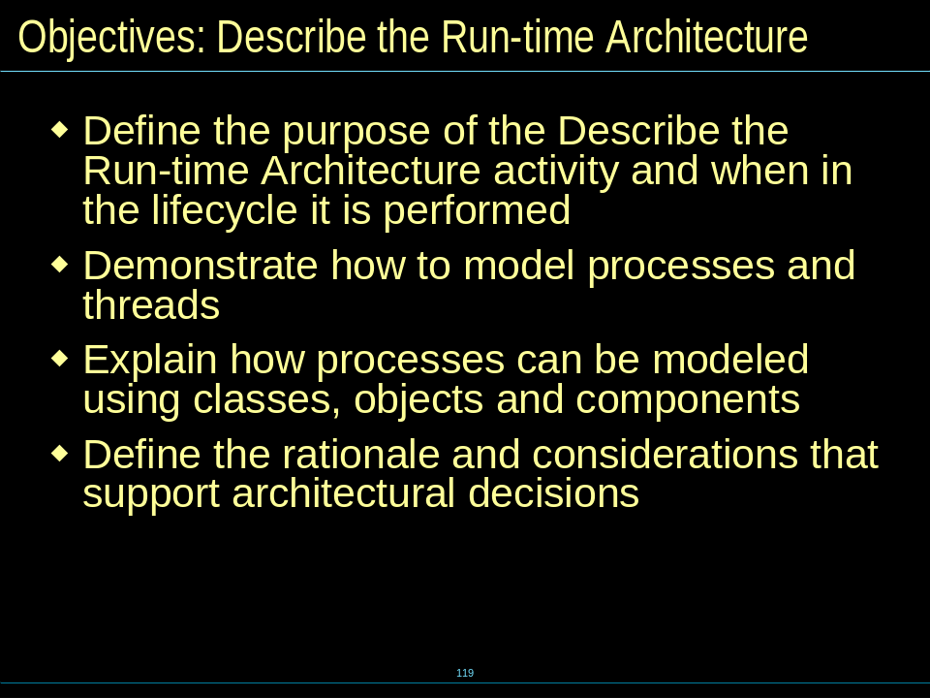

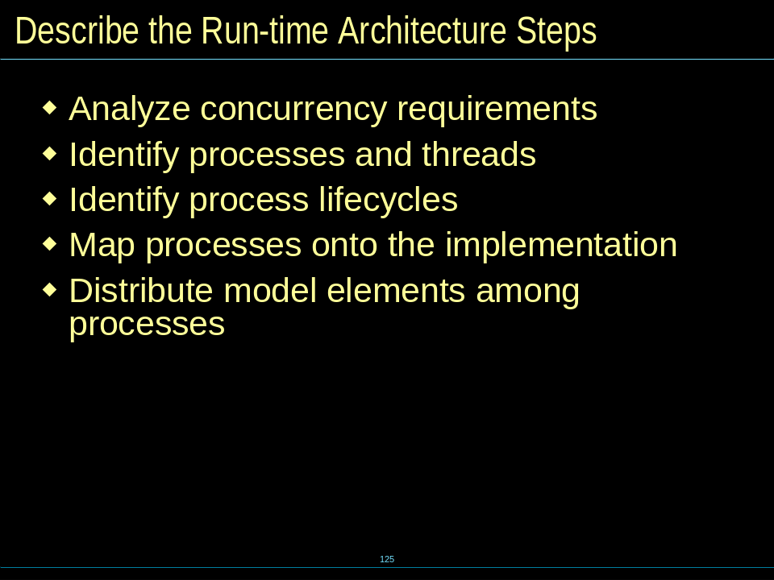

Describe distribution
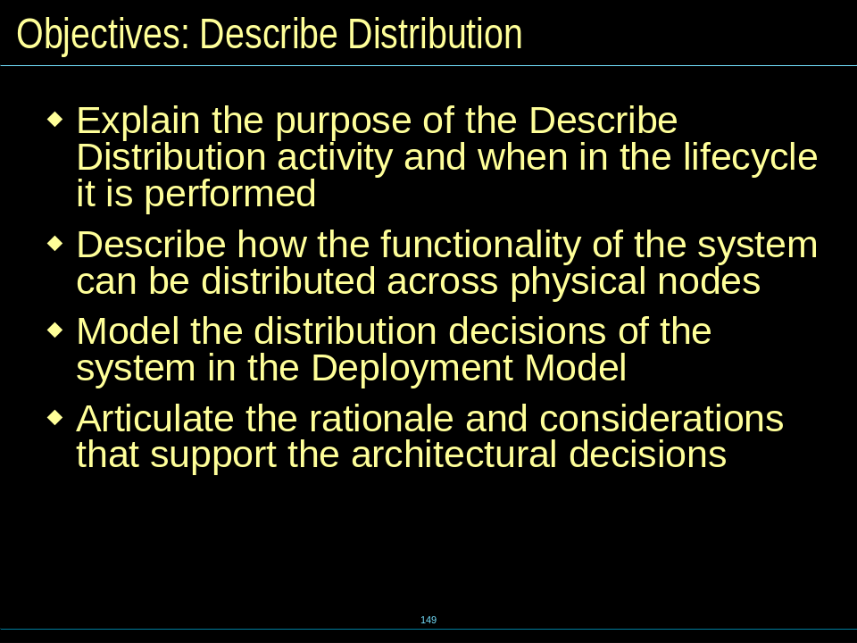

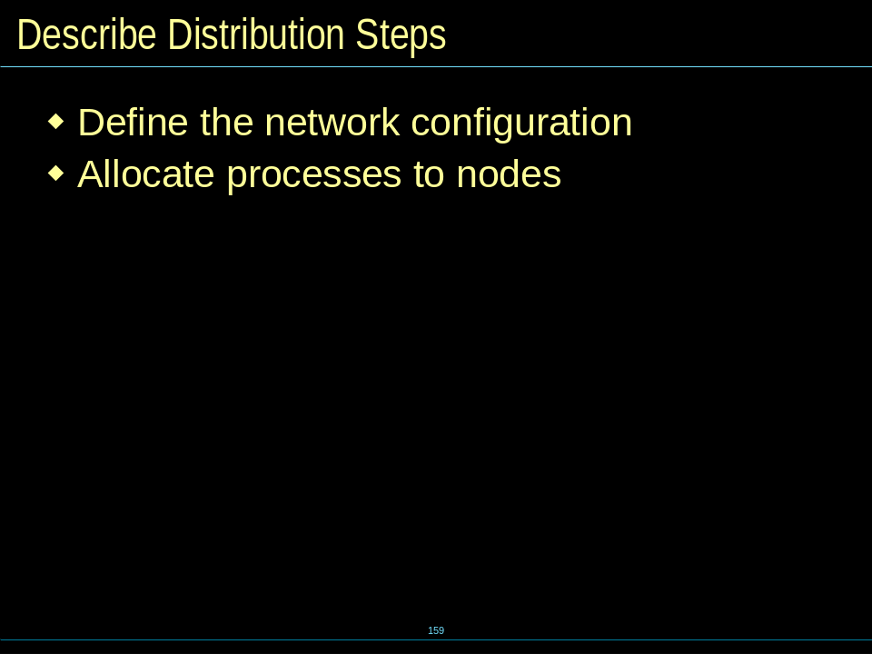

Distribution patterns----C/S(3 Tier)
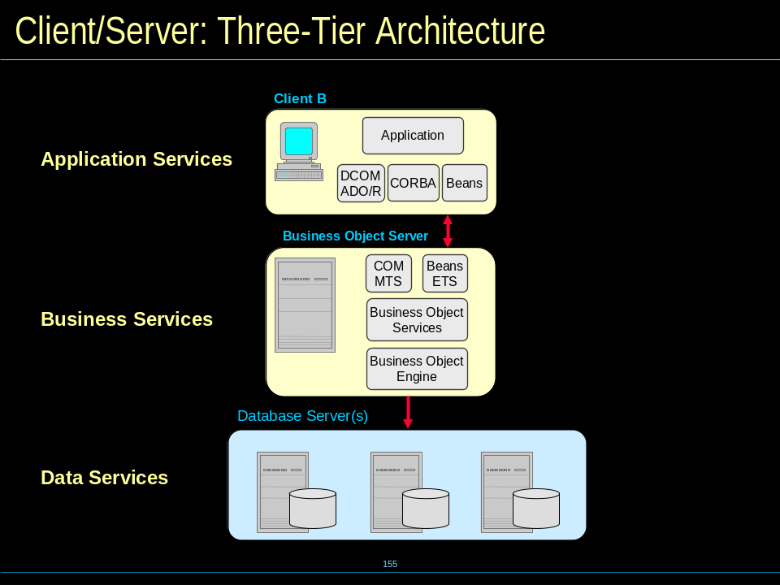

P2P
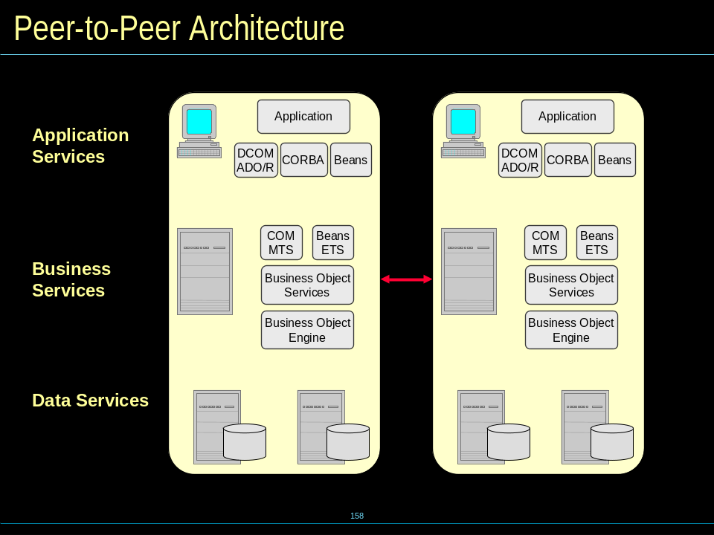

Use Case Design
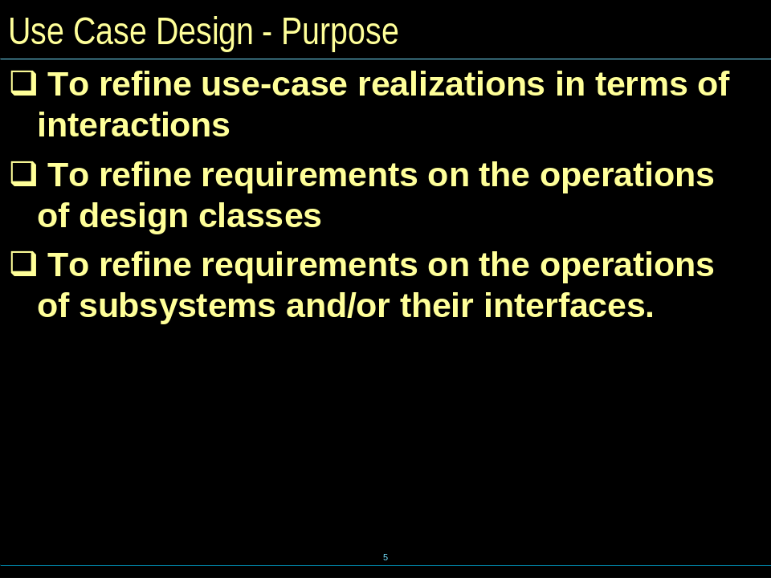

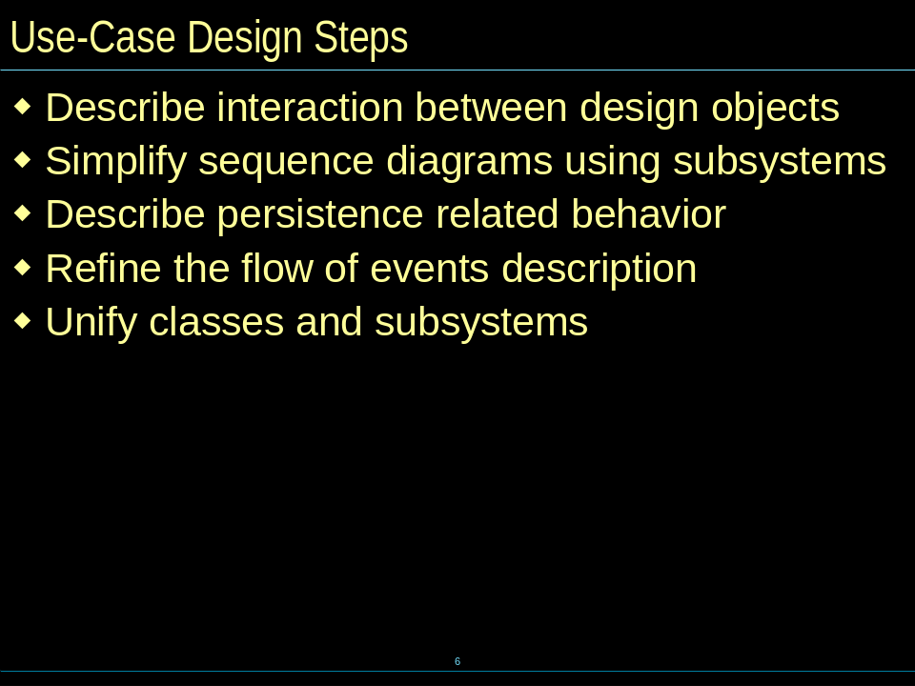

Subsystem Design
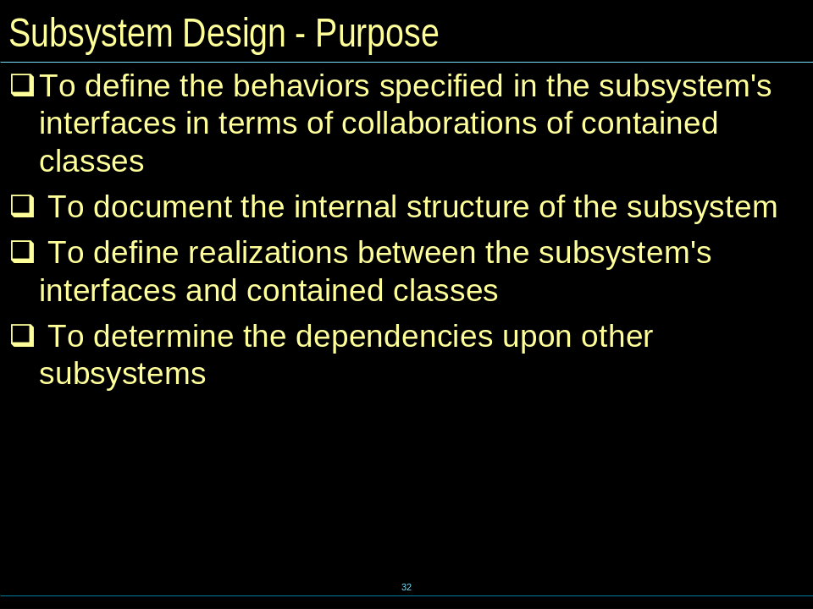

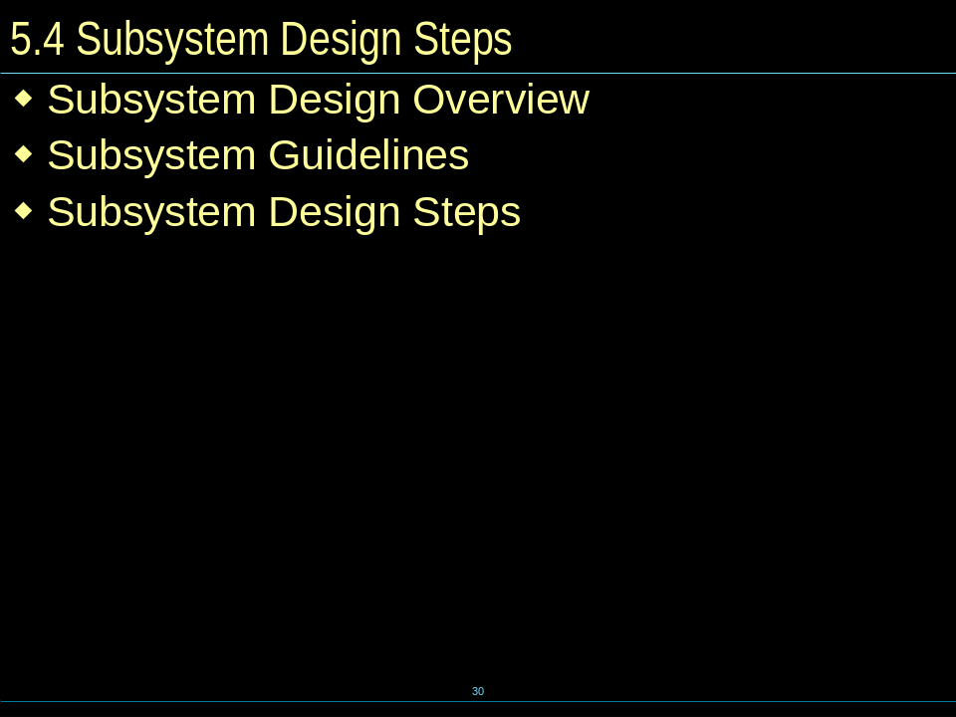

Class Design
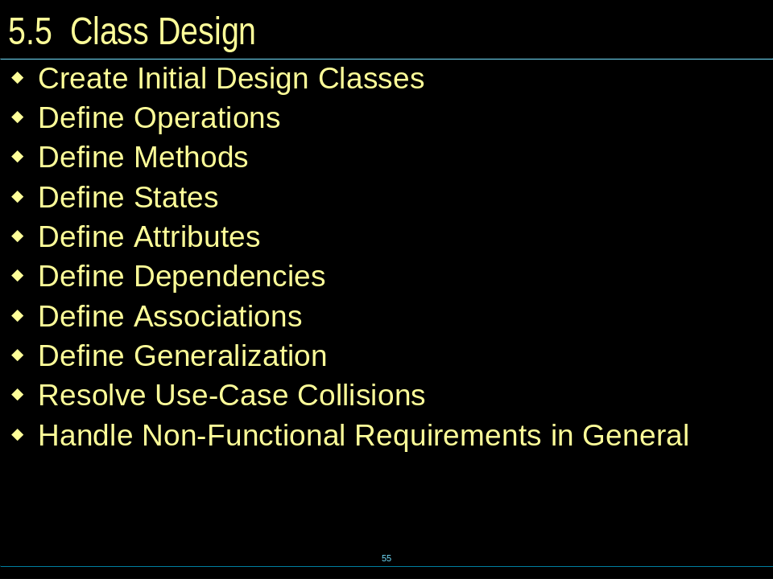

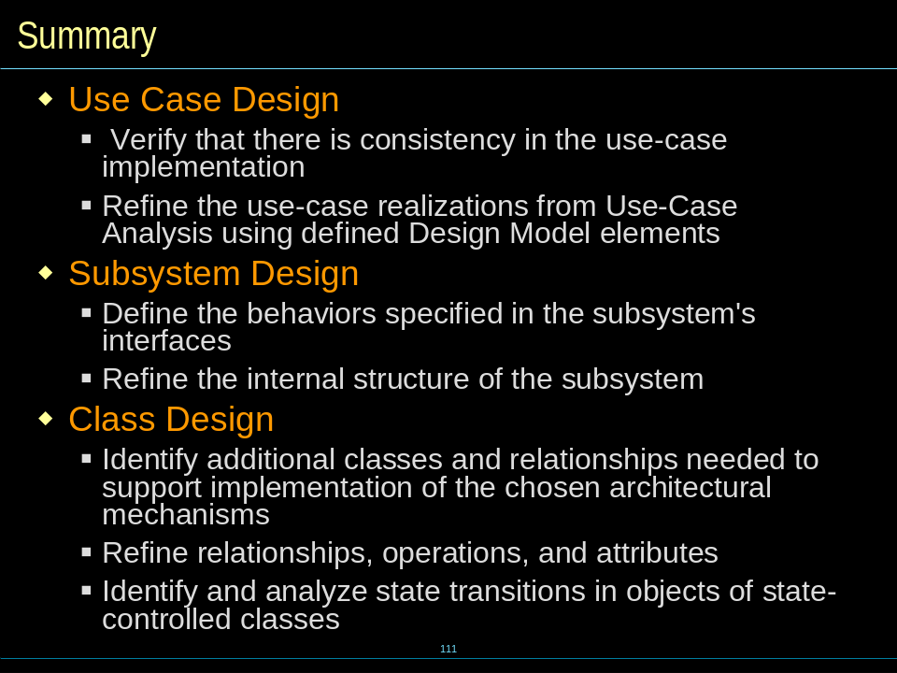

——CH6
The Relational Data Model and Object Model
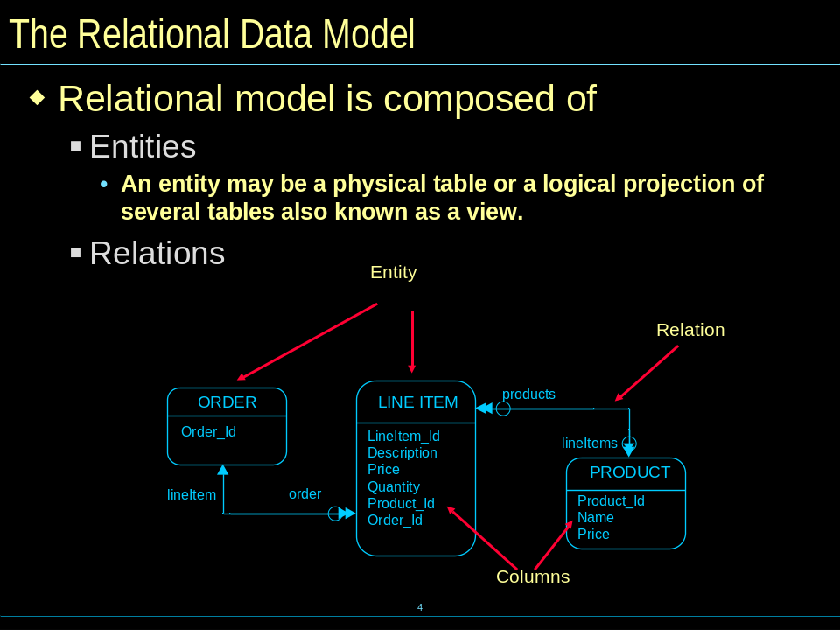

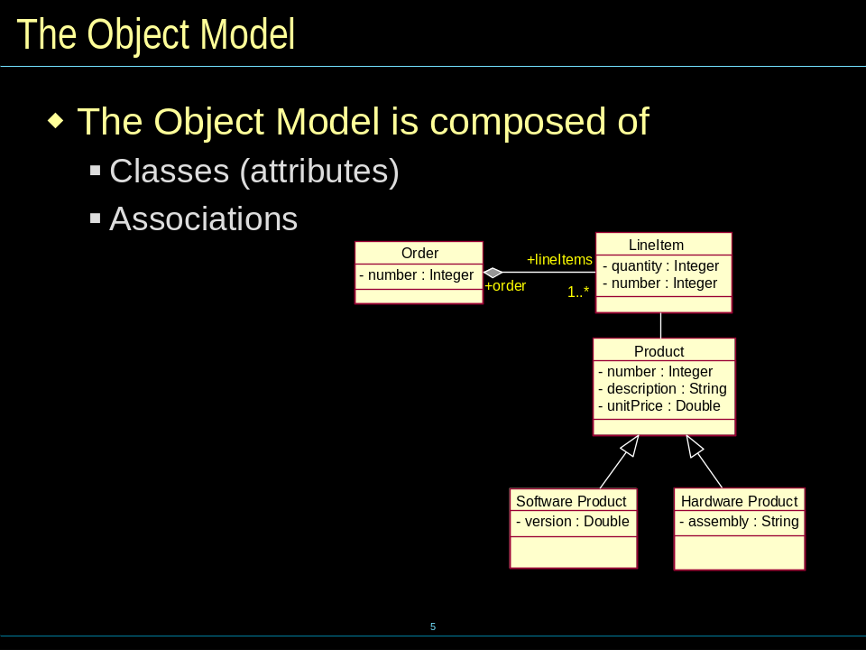

What is Persistence Frameworks
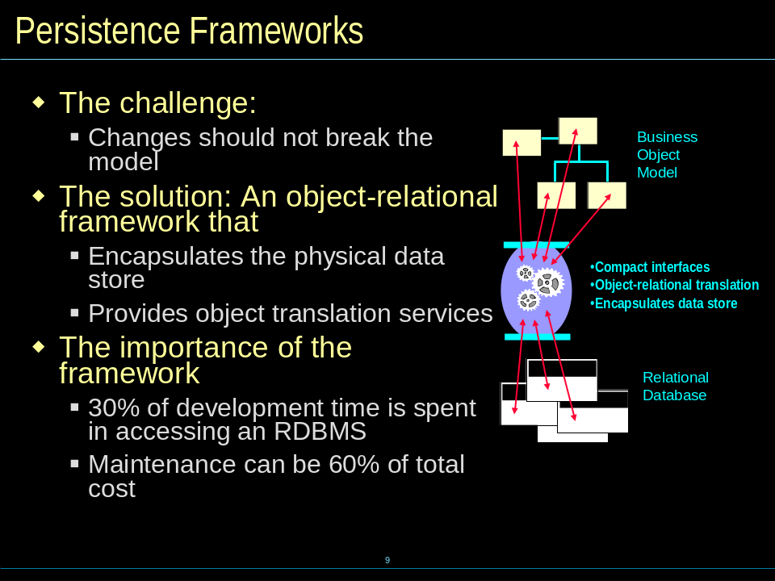

Database Design
